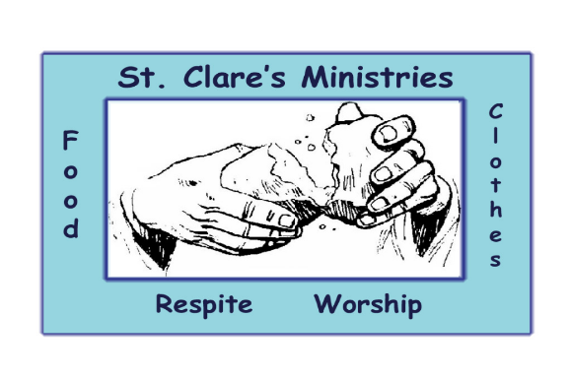

St. Clare’s Ministries

A Diocesan Institution and

A Jubilee Ministry Center

of the Episcopal Diocese of Colorado

126 West 2nd Avenue, Denver, CO 80223
303-722-8781

August 13, 2026
Front Range Region Executive Committee
Report regarding 2026 Grant to St. Clare’s Ministries:

St. Clare’s Ministries is pleased to submit this report to the Regional Missioner and front Range Plains Regional Committee. We thank you for your generosity which continues to allow us to provide our services to the homeless population in the Baker neighborhood.
St Clare’s Ministries’ mission is to offer short-term respite from the harsh realities of homelessness and poverty; and the isolation felt in the absence of a spiritual community. Each person utilizing the services of St. Clare’s is a guest at our table and is referred to as such.
Use of Funds

Every Tuesday St. Clare’s offers a spiritual service followed by a warm meal, and the opportunity to visit our “closet” for basic necessities such as coats, shoes, blankets, and toiletries. Regardless of weather, volunteer numbers, or holiday, St Clare’s remains open 52 weeks of the year as our guests trust that they can depend upon our services being available. Many return weekly and see St. Clare’s as their community and a place to belong. Many report that St. Clare’s treats them more like family than “burdens on society, untouchables, or person not to be trusted.”

This is genuinely articulated by Levi, a repeat “guest” for our Tuesday night services:
“ It’s honestly kind of shocking to see so many people that are helping other people in need. I was definitely one of those people in need. St. Clare’s has kept me fed, provided me with this I needed like clothes, given me prayers, and honestly just gave me a place to go when I needed it most. It’s a real community here, with good energy all around. I’m really lucky.”
Your generous award of $10,000 in 2026 is being used to cover the cost of meals and augments the clothing donations with additional basic necessities, such as toiletries and other hygienic supplies, as the number of our guests has risen in the past year along with food costs. The Front Range Region churches rotate to volunteer to assist with the spiritual service, cook, serve the meal, and staff the clothing closet.

The following is a summary of the services offered from January 1, 2026, through July 30, 2026:
- Warm, nourishing, and well-balanced meals were served to 3565 guests.
- Basic necessities such as shoes, hats, toiletries, and sleeping bags were provided to 1501 guests.
- Spiritual services have been offered to an average of 12 guests per week, thus creating an essential lifeline and spiritual community where none previously existed.
- More than 1200 volunteer hours have been donated to cook, serve meals, visit guests, operate the essentials closet and conduct worship.

Significant Developments

- During 2025 St. Clare’s Ministries was averaging approximately 100 meals per week and 50 guest visits to the essential’s cupboard. This year we are averaging 119 meals per week, and 60 guests visits to the essential’s cupboard.
- To provide further information about St. Clare’s ministries we have begun a quarterly newsletter, and established cards and pamphlets to hand out to the homeless, other persons, organizations, and parishes to let them know of our services.
- St. Clare’s Ministries has hired a part-time security guard for the hours of service. This complies our lease agreement with St. Peter and St. Mary. This security person will be in plain clothes, and will primarily mediate disputes and assist should someone become disruptive. Even though those occasions are rare they can be upsetting for the other guests enjoying our services, who often times suffer from mental illness.
- Because of the increase in the number of guests weekly, we have increased the weekly cost of meal allowance for the cooks and increased the number of sleeping bags distributed per week from 5 to 10. If someone receives a sleeping bag, they are not eligible for another for a period of at least 6 months.
- Due to the extreme temperatures St. Clare’s has begun distributing hydrating powders that can be added to the water we set out in advance of our services on Tuesdays. We have also established a mister system to keep our guests a bit cooler.
Well Being of the Ministry
St. Clare’s Ministries has consistently operated since the 1970’s and will continue to serve our guests 52 weeks per year into the future if funding prevails. St. Clare’s Ministries receives donations from other Episcopal churches, individuals, Board of Directors, companies. This year we are increasing our efforts to be more visible and active in working with other organizations who can provide clothing, shoes, and toiletries or provide funding.

We feel extremely blessed to be able to provide our services to our guests in need and remain grateful for your financial support.
Please enjoy our Newsletter for the 2nd Quarter of 2026 which is attached.

Blessings,
Christine Beck, Treasurer

