2026 Brigit’s Bounty Giving Garden Grant
COMPLETION REPORT
Submitted by Brigit’s Bounty Community Resources

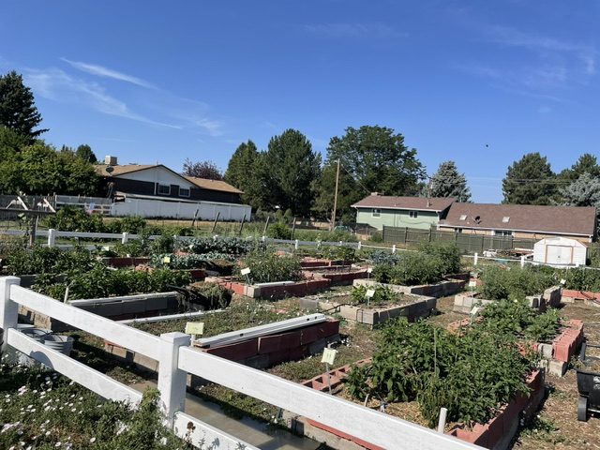
We are very grateful for the $10,000 grant received from the Front Range Region this year for several of our projects at Brigit’s Bounty! The remainder of the expenses were covered through additional grants received, as well as generous matching funds from individual donors and organizations, and St. Brigit church.
Brigit’s Bounty Community Resources, 2026

Projects for this grant included:
--Build a small storage barn for storing supplies and equipment for the garden
--Expand garden plots to increase harvest donations
--Purchase and maintain a Community Fridge to provide food for our neighbors and offer a way for neighbors to share their food.
--Sponsor a student art contest that asks preschool through high school students to depict the joy of gardening, plants, and sharing with the community.

Barn
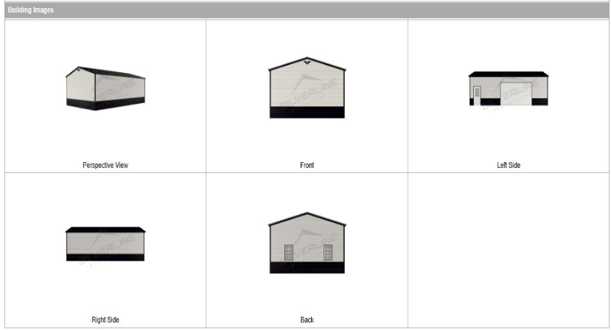
All $10,000 of the Front Range grant money received was used towards purchasing the barn. Separate funding was found for the remainder of the barn cost via private donations and the Town of Frederick. A barn kit has been purchased, and we are waiting on city permits to begin construction. Brigit’s Bounty also received a different grant to hire a muralist who will paint a mural on one of the sides of the barn after the barn is complete.
- Barn expenses - Includes the barn kit, concrete, permit, improving location survey, design documents, & skid steer rental to move base pile: $35,000

Expanded garden plots
We added several garden beds, thus expanding the harvest anticipated for 2026. Volunteers provided labor and supplies.
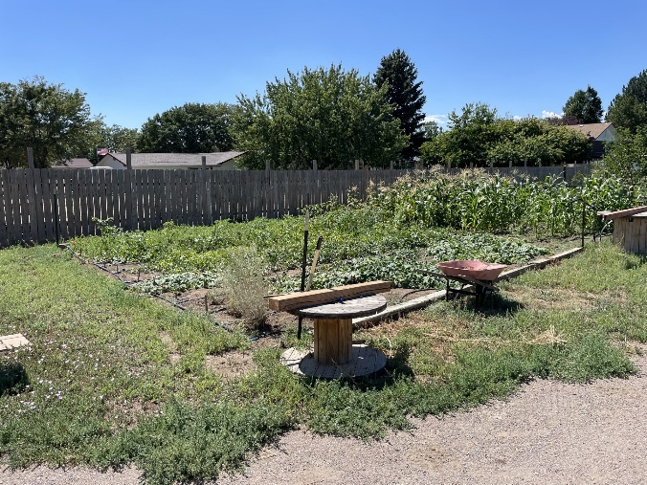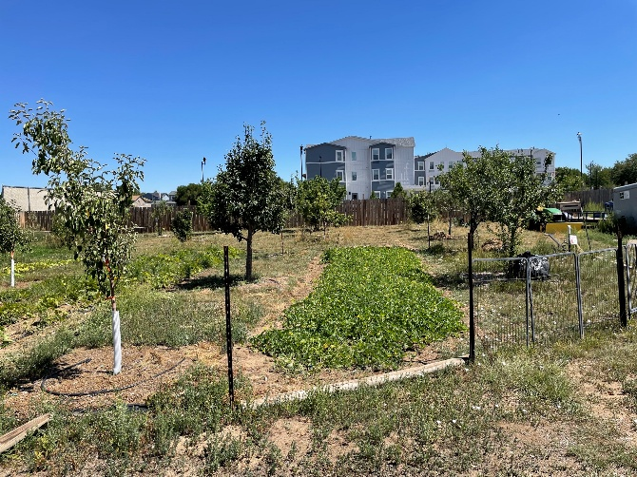
Expanded growing area Expanded area utilizing agroforestry in the orchard
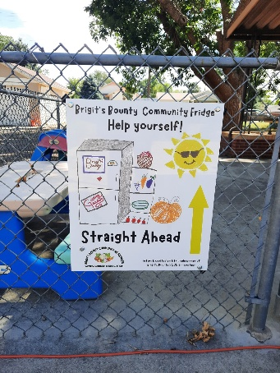
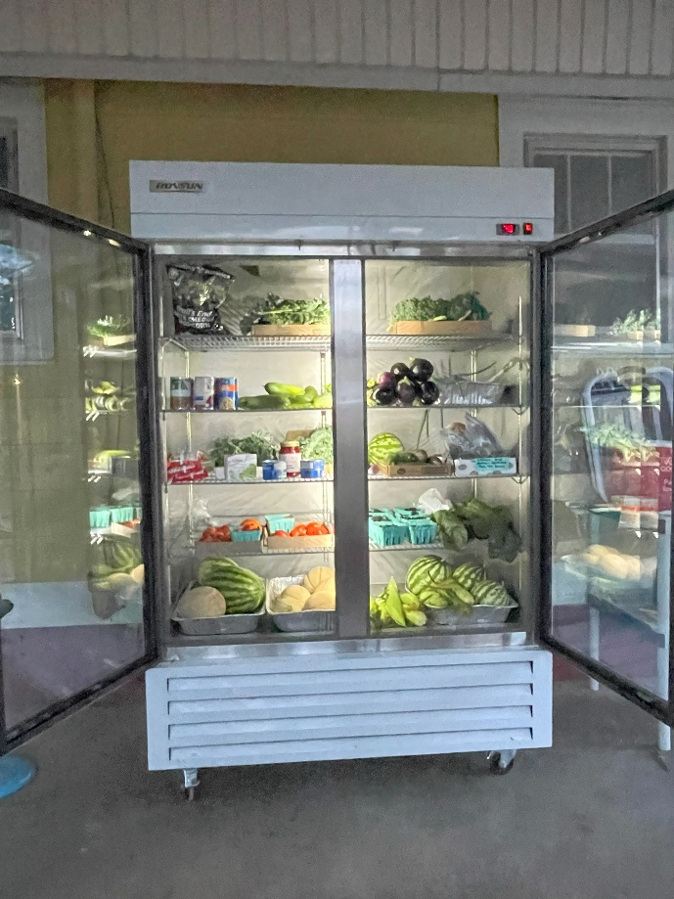
Community Fridge
Through donations from the City of Frederick, private donations as well as discounts from Home Depot, we purchased a double-wide commercial refrigerator and installed directional signage, which is now set up in a semi-enclosed area by the St. Brigit administrative offices. Three signs, donated by FastSigns in Longmont and utilizing student art from the art contest, guide visitors to the Fridge location. In mid-August we set out our first donations of produce from the community garden. This community fridge will be available 24/7 for anyone in the community, which will include fresh produce from Brigit’s Bounty as depicted in the picture.

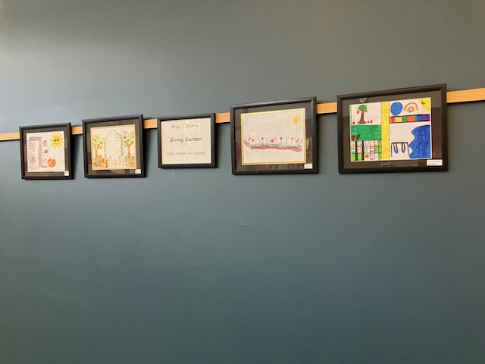
Student Art Contest
There were 14 entries from the Student Art Contest selected as winners and semifinalists; each received cash prizes. An exhibit to showcase the student art has traveled to St. Brigit Episcopal Church, High Plains Public Library, and MECO Coffee Collective in Frederick. The exhibit will also be shown at the Senior Center in Firestone, Brigit’s Village affordable housing, and potentially the 139th Episcopal Diocesan Convention held in October. Discounts from Michael’s Arts and Craft Store, and private donations, covered these expenses.

