ST LAURENCE EPISCOPAL CHURCH
26812 BARKLEY RD
CONIFER, CO 80433
August 21, 2025
To Whom It May Concern:
The repaving of the parking lot at St Laurence Church in Conifer, CO was completed on June 17. 2025. Cost breakdown was as follows:
Donations from members: $20045
Grant from Regional: $9700
From church reserves: $5291
Total Cost: $35036
Striping was done at no cost by volunteer members.
The St Laurence congregation is very grateful for the assistance the Front Range Regional District gave us for this important project.

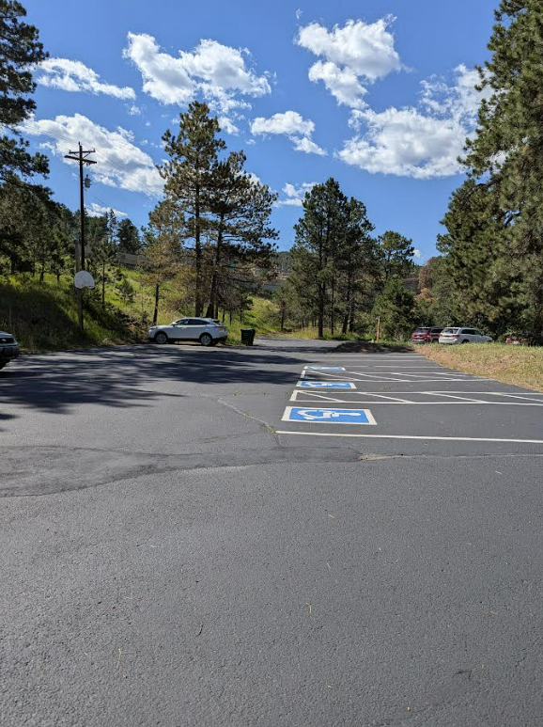
Sincerely Yours,
Dan Lincoln
Project Manager

