Christ the King Arvada

**Grant Report to the Front Range Region of the Episcopal Diocese of Colorado**

August 8th, 2025

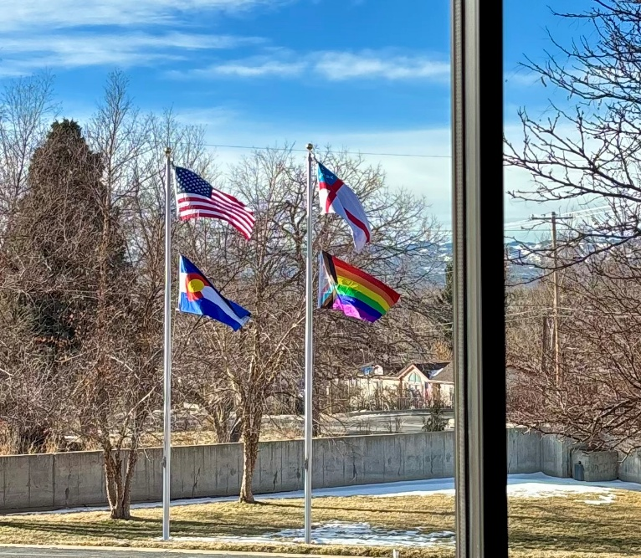Thanks to the generous grant of $2050, we were able to install flagpoles in our parking lot to signal our message of welcome and acceptance to the community. The total cost of the installation was $4050. We had a matching donation from the Colorado trust that covered the rest of the cost for installation. Additionally, we spent $70.01 on four flags—USA, CO, The Episcopal Church, and The LGBTQIA2+ inclusive rainbow flag. Finally, parishioners donated an additional $1000 for the future installation of lights for the poles.

The mission has been an overwhelming success. Since voting to become an officially welcoming and accepting parish and a member of the Believe Out Loud program, we have seen a slow, but steady trickle of interest and new attendees—both from members of marginalized communities and their allies. We have also received letters of support and encouragement from the local neighborhood community who are pleased to see an open and accepting church publicly displaying a message of inclusion in their area.

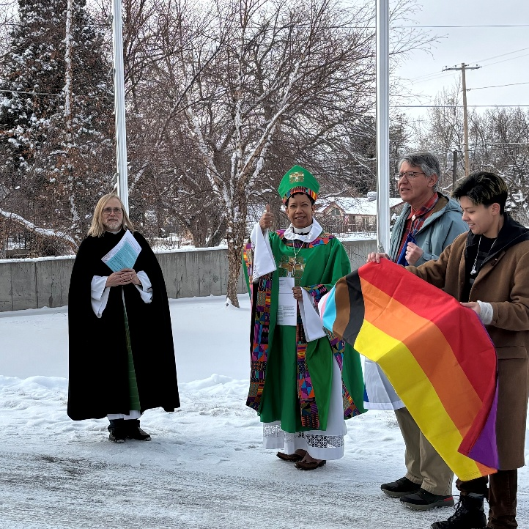We believe that as we continue to display our message of welcome and inclusion we will continue to move toward self sufficiency for further missions of outreach. The vestry would like to thank the Front Range Region for its continued support of our parish and mission. Without your help, we would have been unable to display these outward signs of our commitment to our baptismal covenant to respect the dignity of every human being.