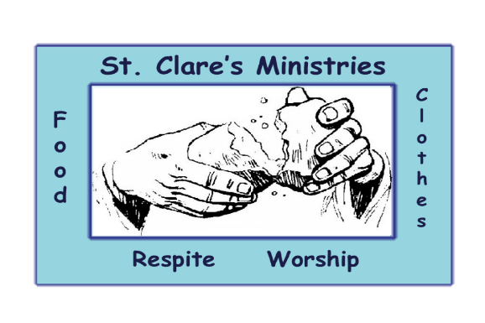
St. Clare’s Ministries

A Diocesan Institution and

A Jubilee Ministry Center

of the Episcopal Diocese of Colorado

126 West 2nd Avenue, Denver, CO 80223
303-722-8781

2024 Grant Report

August 19, 2024

St. Clare's Ministries is grateful for the $10,000 grant awarded by the Front Range Region for 2024. The award is being used to build a loving and welcoming community through feeding and clothing the homeless and working poor in Denver.
2023-2024 brought a number of changes to personnel and operations in the organization. In February 2023, the Board of Directors elected a new Chairperson, Nathan Farr, and in September our Managing Director stepped down to pursue a seminary program at Denver University’s Iliff School of Theology. We were blessed to quickly find a replacement in Rev. Patrick Wilson and had about a month of overlap to get him trained and comfortable with the role. Patrick is devoted to the mission and vision of St. Clare’s and has been a key part of our success. Lastly, the Treasurer of St. Clare’s, Michael Wise, retired at the end of 2023 after 14 faithful years in the role. While we’re still searching for a successor, we’ve engaged a bookkeeping service to manage day to day financial activities and brought on two new board members with a financial background.
Operationally, St. Clare’s made two critical changes in early 2024, spearheaded by Deacon Nadine Pope of Good Shepherd in Centennial and Glenda Whited of Christ the King in Arvada, both members of the Board of Directors. The first was to reinstitute an optional church service, which was paused due to the Covid pandemic, but is a core element of the St. Clare’s mission. Second, our process for distributing clothing and toiletries was challenged by the increased number of visitors. We evaluated options to be more efficient with our time, costs, and space to serve as many people as possible during our business hours. We successfully implemented both the church service and the process improvements in March 2024. We now have active and retired clergy from supporting parishes volunteering to celebrate the eucharist, with 5 to 10 guests attending the service each week. The Clothing Closet has several new processes to get people in and out quickly and to manage inventory. This has kept us significantly under budget, and able to serve guests in a timely manner.
St. Clare’s Ministries served nearly 4,000 meals from January through July 2024, averaging 119 meals per week at an average cost of $254. We average 52 visitors to the Clothing Closet each week and have stayed well under budget. The Clothing Closet is the largest expense at around $2,500 per month, but this is an improvement over 2023’s cost of nearly $3,500 per month for the same period. We average 16 volunteers each week from 9 different parishes and were even blessed to have the Denver University Women’s Basketball Team serve for one week in July.
One of the most meaningful developments this year is a growing sense of community among our guests and volunteers. Guests have commented that the atmosphere is just different at St. Clare’s compared to other organizations. Volunteers and guests greet each other by name. Guests have inquired after volunteers if they haven’t seen someone for a while, and vice versa.
Your support makes this happen. On behalf of the Board of Directors, our many volunteers, and guests, thank you for giving to St. Clare’s Ministries.

Sincerely,

Nate Farr
Board Chair
720-490-9435
nathanrfarr@gmail.com

