St. Luke’s Episcopal Church

Fort Collins, CO

Regional Grant Report

August 20th, 2024

St. Luke’s Church is committed to fulfilling our Christian calling to care for creation and combat climate change. Our pursuit of an energy-efficient building project is a testament to our faith and demonstrates our dedication to both revitalizing our church premises and embracing our welcoming mission. We aspire to become a pioneering model for aging churches, demonstrating the potential to serve as resilience hubs for our local communities while promoting climate-friendly, carbon-free practices.

This endeavor was instigated by the urgent need to replace our aging gas boiler. Further concerns arose during the COVID-19 pandemic when we discovered that our building lacked proper ventilation, leading to stagnant indoor air. Notably, one of the primary sources of indoor air pollution was our gas range in the kitchen. Armed with new knowledge about the health risks associated with gas stoves, we made the conscientious decision to disconnect the gas supply, rendering the stove inoperative. This choice was rooted in our commitment to safeguard the health of several vulnerable groups within our church community. We sought to protect the children attending our adjacent preschool, the members participating in parish hall activities, including ministries, social events, and funerals, as well as a congregant with health issues who faced breathing difficulties while near the kitchen.

Securing funds for replacing the aging boiler was an ongoing challenge and a priority, so our disconnected stove remained inactive for several months. We operate multiple ministries that heavily rely on the kitchen and stove and are launching a daycare facility in September that requires a functioning stove, washer/dryer and plumbing work in the daycare rooms. This led us to apply for the regional grant to get the kitchen up and running again as soon as possible.

Thanks to the regional grant, St. Luke’s has a working kitchen again! The grant covered the cost of installing a new energy efficient induction-top range with a double oven as well as the necessary electrical work, with funds left over for the plumbing and electrical work needed for our daycare’s washer and dryer and new sinks. Although the grant covered much of the cost, the generosity of a parishioner who donated a used electric stove, the hard labor of a few of parishioners and volunteers from a community meeting who helped to remove the old commercial gas range and an electrician who gave us a very good rate on the electrical work allowed us to accomplish our goal way under budget.

Since installing the new stoves, we have used them for eight large functions that served over 100 people each, including a luncheon in honor of the bishop’s visit.  The stove has also been used by our preschool, our youth group, for grant committee meetings, ministry meetings and for small group events.  Next month we have a Beers, Brews and Brats event that is open to the community and an EV charging station installation kick-off event (date TBD) that will be open to the public in addition to several other events on the horizon. With our new ovens we will be able to provide refreshments and meals at these events. All done without a polluting gas range on the other side of the wall of our daycare and near the parish hall!

A washer and dryer were donated by a local realtor and a parishioner respectively, and several strong, young parishioners volunteered their time and muscle to deliver them to the church.  They have been used to launder the event tablecloths and kitchen towels that previously sat in a huge pile, waiting for volunteers to take them home to wash. The kitchen and laundry area are now ready for use by the daycare which will open this September.

We were able to complete the kitchen project well under our original cost estimate.  The following kept our costs down:

1. A parishioner purchased and donated a high-end used electric double oven - savings about $3,499.
2. An electrician friend found a work-around to pulling the electrical from the far end of the building and gave us a very good deal on the cost of his labor.  Savings us about $8,500.
3. We gave away the old gas range through Facebook and a small group of volunteers helped move the massive old thing out of the building - savings about $1k on removal and recycling.
4. A parishioner purchased and donated cookware for the induction-top stove.

The grant funds were allocated as follows:

$3,499.99 - New Induction-top energy-efficient electric range

$1,665.00 – Electrical wiring

$   100.00 - Donated stove check-up

$1,373.79 – Electrical wiring and plumbing for washer/dryer installation

$ 611.22 – Applied to costs for new daycare electrical, venting and plumbing work

Since updating the kitchen and adding the laundry facilities we have held a successful capital campaign, spurred on by the boiler dying in January. Our community braved the cold classrooms and services wearing parkas, wrapped in blankets and sitting near our few fuse-blowing space heaters. Our capital campaign raised enough money to cover the cost of the boiler replacement as well as solar panels with a small back-up battery, heat pumps for our daycare classrooms and a design to convert our turf to a low-water need xeriscaped area. The success with our kitchen energy upgrade made a huge difference in the quality of the air in our parish hall and kitchen and encouraged the congregation to continue to pursue the other creation care and energy efficiency work. We have since replaced our lighting with LED’s using a full grant from the local government. This fall we are installing six EV charging stations fully funded by local incentives and a state grant. St. Luke’s looks forward to working together to make our churches and communities safer, healthier, and more sustainable and we are grateful for the assistance from the Front Range Regional 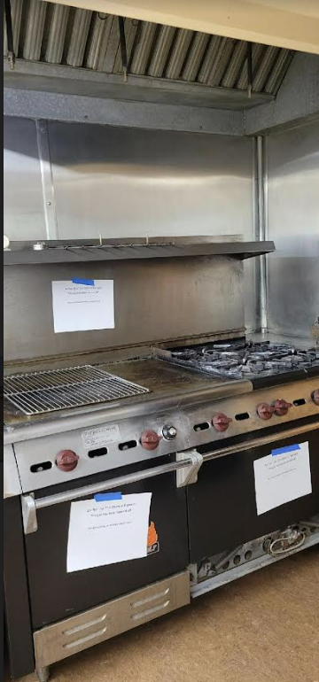Grant for getting our kitchen and laundry up and running quickly!

