St. Joseph Episcopal Church
Peter von Hemert, Junior Warden
11202 West Jewell Avenue
Lakewood, CO 80232
303-985-7170

Front Range Grant Committee
Bethany Pedersen, Regional Administrator
2422 Colorado Avenue
Boulder, CO 80302
August 19, 2024

Report from St. Joseph Episcopal Church
on the accounting and use of
our Regional Grant for 2024

Accounting:

Grant $3500.00

Spending to date -
Pop-up canopies (4) $781.92
Banner structure $207.76
Vinyl banner (4) $238.52
Changeable acrylic banner (2) $394.78
Paper goods & copying $ 96.89
Copying
Table easels and whiteboards (2) $ 93.35
Online advertising $ 30.00

TOTAL SPENT TO DATE $1843.22

REMAINING GRANT $1656.78

Spending anticipated –
Vinyl banner (8) $ 500.00
Improvements to banner structure $ 75.00
Paper goods & copying $ 75.00
Online & newspaper advertising $1006.78

TOTAL SPENT $3500.00

REMAINING GRANT $ 0.00

Use:

We have stayed close to the intent of this grant. The moneys were to be used to increase our visibility within our community. This goal as been achieved. With the infrastructure that the funds has built, we will be able to continue sharing the news of our activities on an ongoing basis. We thank the Front Range Region for their support of our parish’s work to invite others into one of Christ’s welcoming places.

The banners are doing their intended mission. We know this because several of the guests to our events have told us that their attendance is directly due to seeing them. The acrylic banner was not in our original plan. It came about with the idea of creating a way to do short term notices of smaller events. It will allow us to broadcast a bigger message than our current driveway changeable sign.

The pop-up canopies have added a festive and professional look to our events. Before we had to work on borrowing friends of friend’s items. They came in various condition and shape. The four we now have are all the same size, but different colors. This has helped during an event to give directions to those looking for a particular activity.

One of the questions during my grant interview was, “Was it our intent to make them available to the lager community?” I said, “Yes.” Next month they are being lent to one of our neighbor Green Mountain churches for use re-instating their annual outdoor gatherings post-COVID. They are excited to get back to a new normal, and we are excited to be able to help.

We have completed only one online advertising purchase so far. This is partly because of learning how to get access to the medium, and partly because we wanted to make sure of our hard costs. These have turned out significantly less than anticipated. I found a banner producer that charges considerably less than my original estimate. And, low and behold, we have found out that one of our new members is in the marketing business. He has offered to share his gift with us. Prayers are answered.

The paper goods are used in our changeable signs and making fliers to do direct marketing.

The table easels and whiteboards are used at the St. Joseph table, which is at every event. This table is central to our activities. This is the place where we can connect the fun activities that we are offering to our faith. It is a formal place to welcome the visitor. It is a place that can establish a connection between strangers. It is a place to invite the wanderer into a new discovery experience.

Mission Assessment:

The mission initiative of letting the larger community know that we have gifts to give to the community with no strings attached has received a huge boost made possible by this grant. At the very least, the thousands of drivers that pass by the church (major commute route) every day have seen our banners. Our Touch A Truck event doubled over last year. Some of that increase was due to our more visible marking. A fourth of the donors at our blood drive came in because they saw the banner announcement.

Has anyone from these activities joined our rolls? No. But, we have had touches. A dozen asked and were given in-depth tours of the building and grounds. Most visitors were on their first encounter with St. Joseph; the park-like grounds, the playground, the labyrinth, the peaceful spirit. Change of culture does not happen at first exposure. If we want Love to live in as many hearts as possible, we will need to rinse and repeat.

This is where the mission’s initiative is most notable. Some have gone away inquiring if we are going to do ‘this’ again. They want more. Even more significantly, the current parishioners have bigger smiles. They have seen the benefit of their efforts. Now, as a passionate group, we have created a space where, for some moments, all who come to us are welcomed and at peace. It is possible.

What’s next? With hope and His help, one’s dreams are possible.

Self-sufficiency is now a dream we dare to dream. I dare say that in the not-too-distant future, we will once again make this an attainable goal.

Has this grant help this congregation move forward? Yes. As we continue to understand ourselves better and gain confidence, we can be bolder with our actions. As we find partnerships, we can become more effective in our actions. Thank you for choosing to be one of our partners this year.

Respectfully,

Peter von Hemert
St. Joseph Episcopal Church
Junior Warden

Pictures attached:

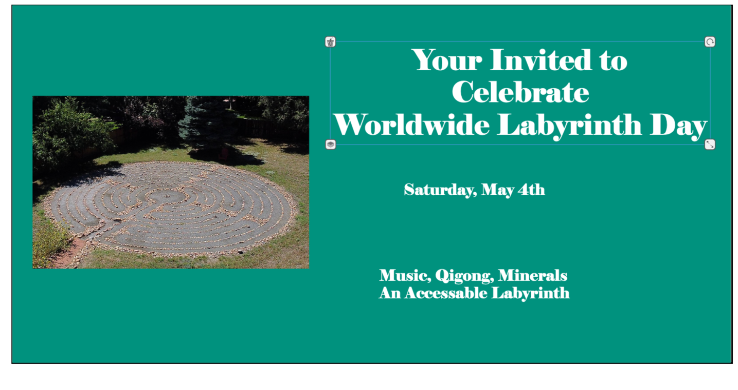
Design for first banner. – When hung the print was too small to be read driving by

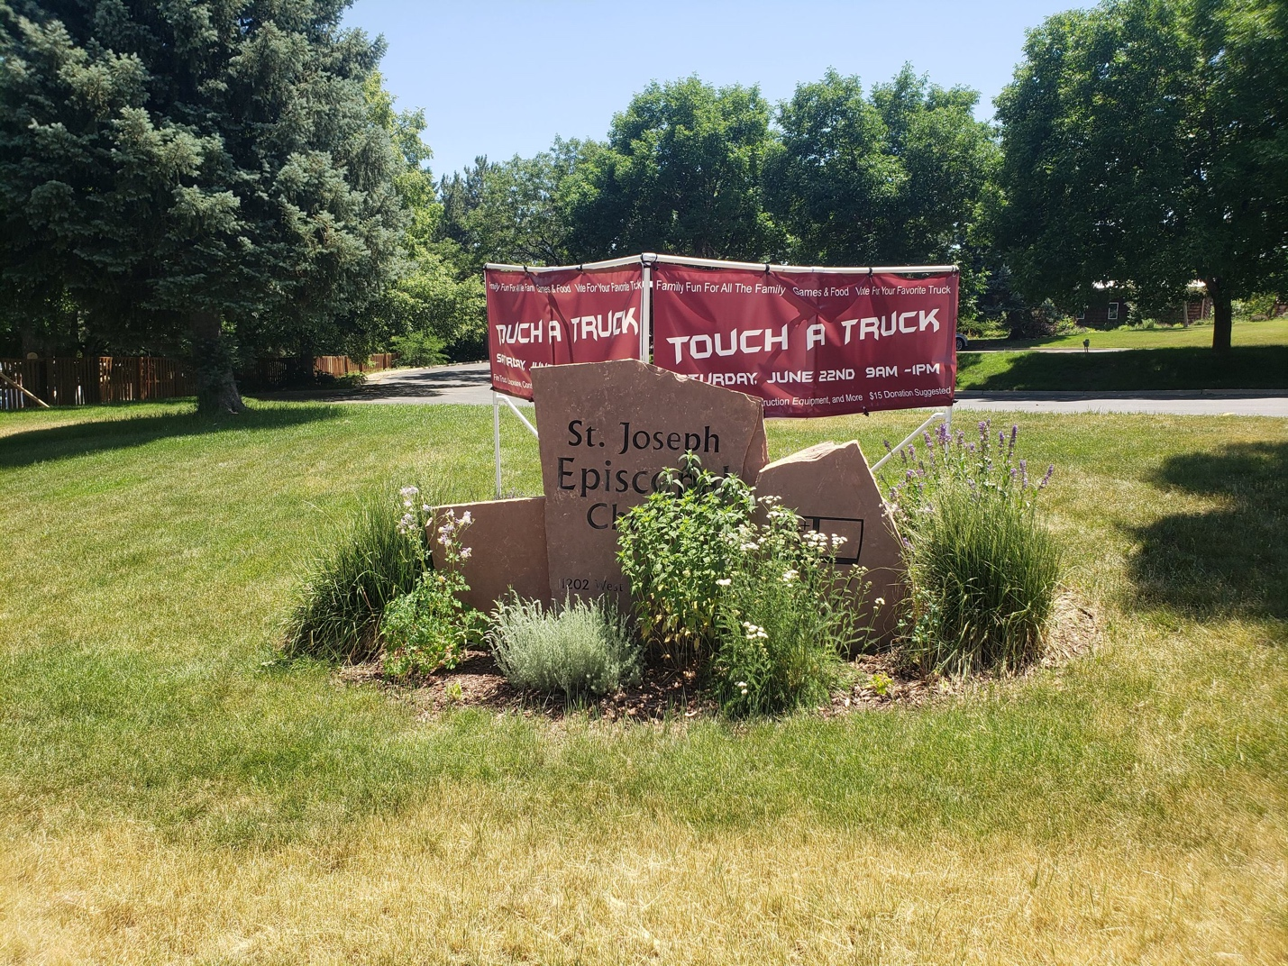

Second banner on structure. – Print size better
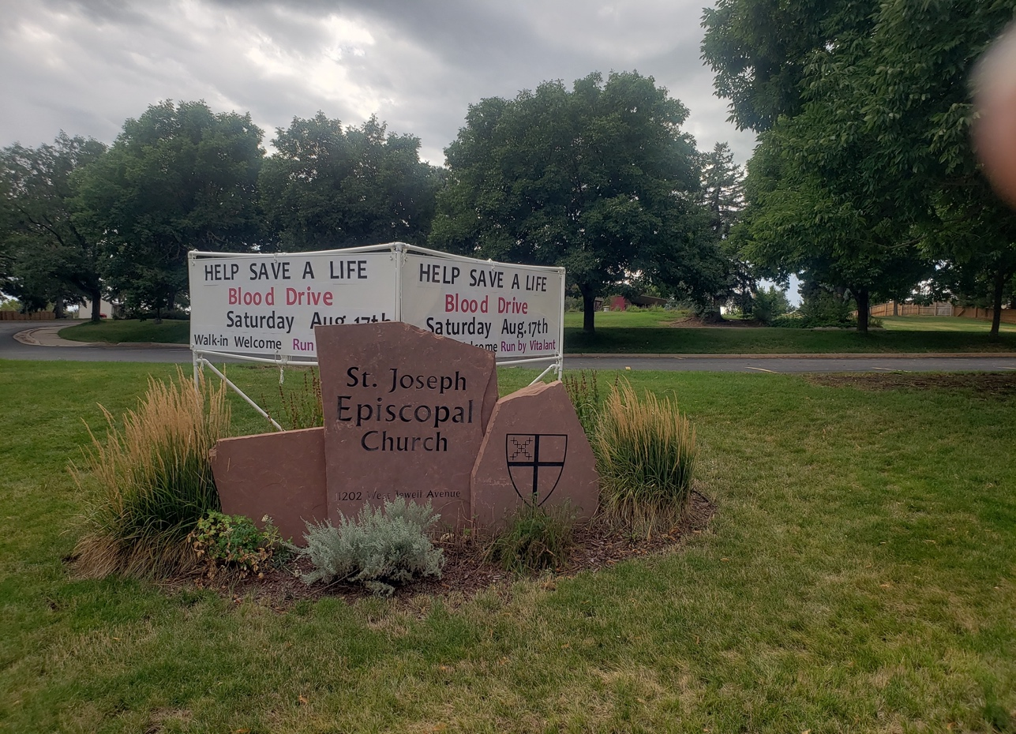

Acrylic changeable banner.

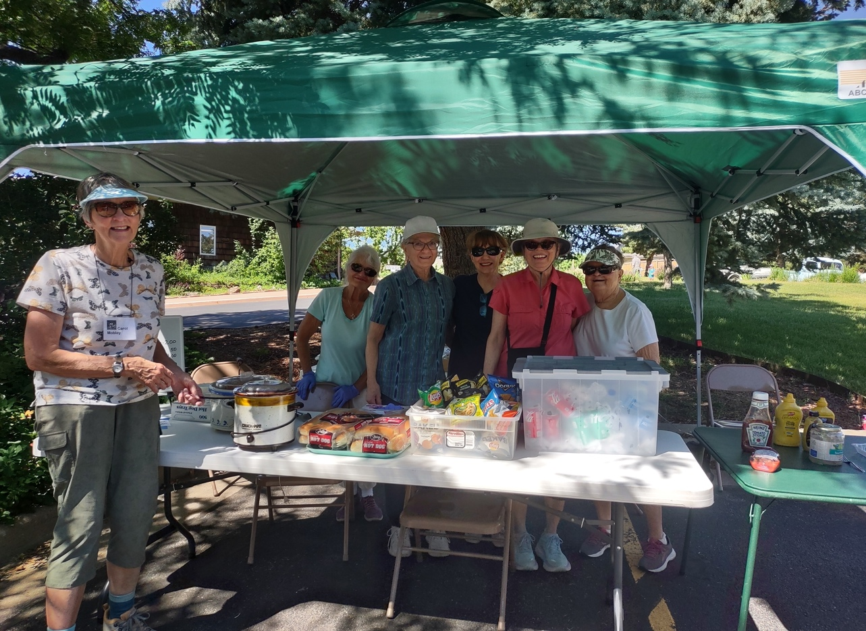

Smiles at Touch A Truck

