Called.
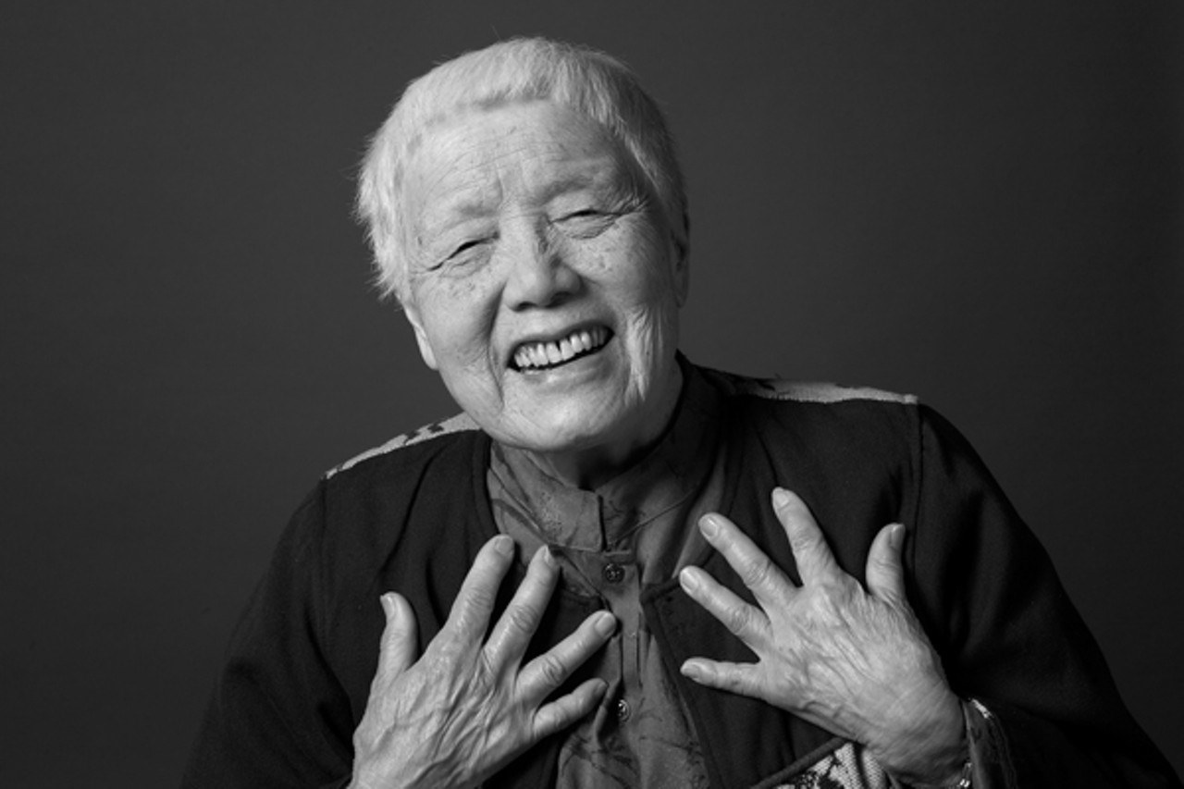
Grace Lee Boggs – an organizer of Chinese descent in the Detroit area has a practice where she would gather leaders and leaders-to-be in her living room filled with her books. Before they launched into strategy or ideas or even an agenda, Grace would ask the question, “What time is it on the clock of the world?”
"What time is it on the clock of the world." - Grace Lee Boggs

Ponder and reflect at your table: At your faith community right now, what time is it on the clock of the world?

Examples:
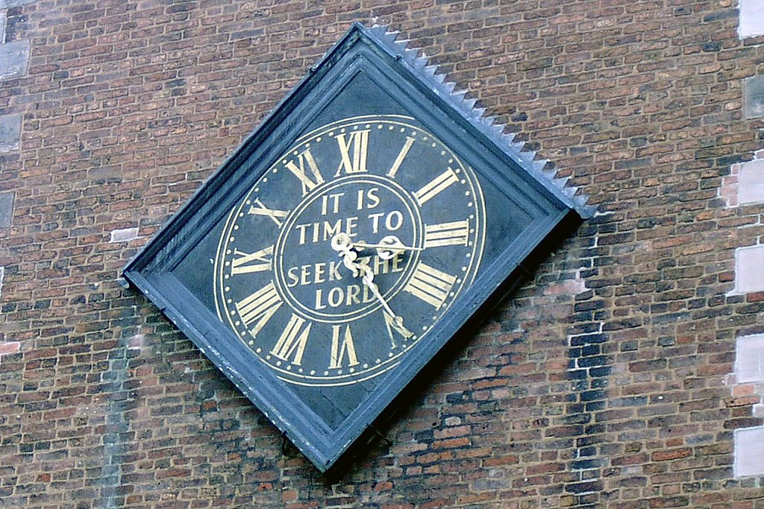
- Dawn... new beginnings
- Sunset... endings with the promise of something new
- Five minutes to midnight... we are running out of time

Gather - Transform - Send

Core purpose of every congregation: to GATHER God’s people in community, be a site of TRANSFORMATION and renewal through worship and congregational life together, and then to SEND God's people out into a world that needs them.
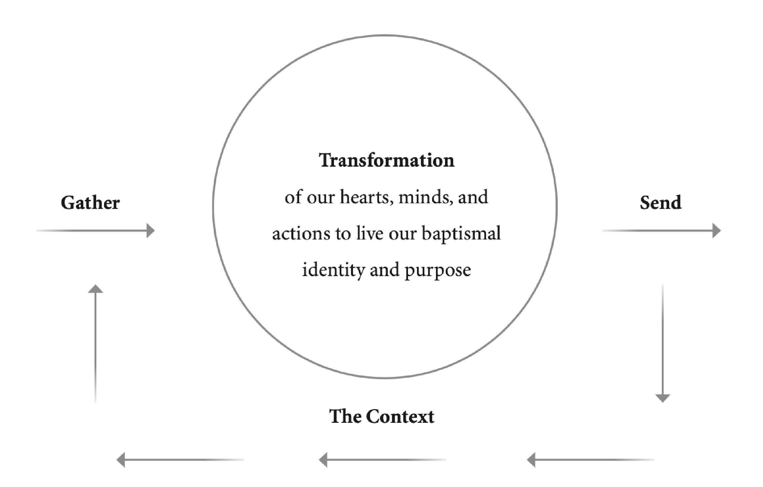

At your table, describe WHY you love your church - without using the words "welcoming", "inclusive" or "family".

Gather

Invite
Everything that happens before someone shows up for worship
- How people talk about your congregation
- Your website
- Exterior signage
- Physical location
- Direct invitations from someone who already attends!
Greet
What meets people when they come in, log on, or otherwise intentionally interact with your community of faith
- Trained greeters
- Untrained greeters
- How newcomers are spoken to and included, maybe even recognized

Orient
The process of learning how "we" do things in "our" church
- Bulletins and printed materials
- Announcements
- Signage
- Formation opportunities
Incorporate
When someone accepts the invitation to make a particular community of faith their spiritual home
- Choosing to be baptized, received, or confirmed
- Transferring membership
- Attending a new member ceremony
- Saying "yes" to a lay leadership position or participating in a ministry
- Financial support of the community

What was going on in your life when you started attending your congregation and how were you INVITED and GREETED?

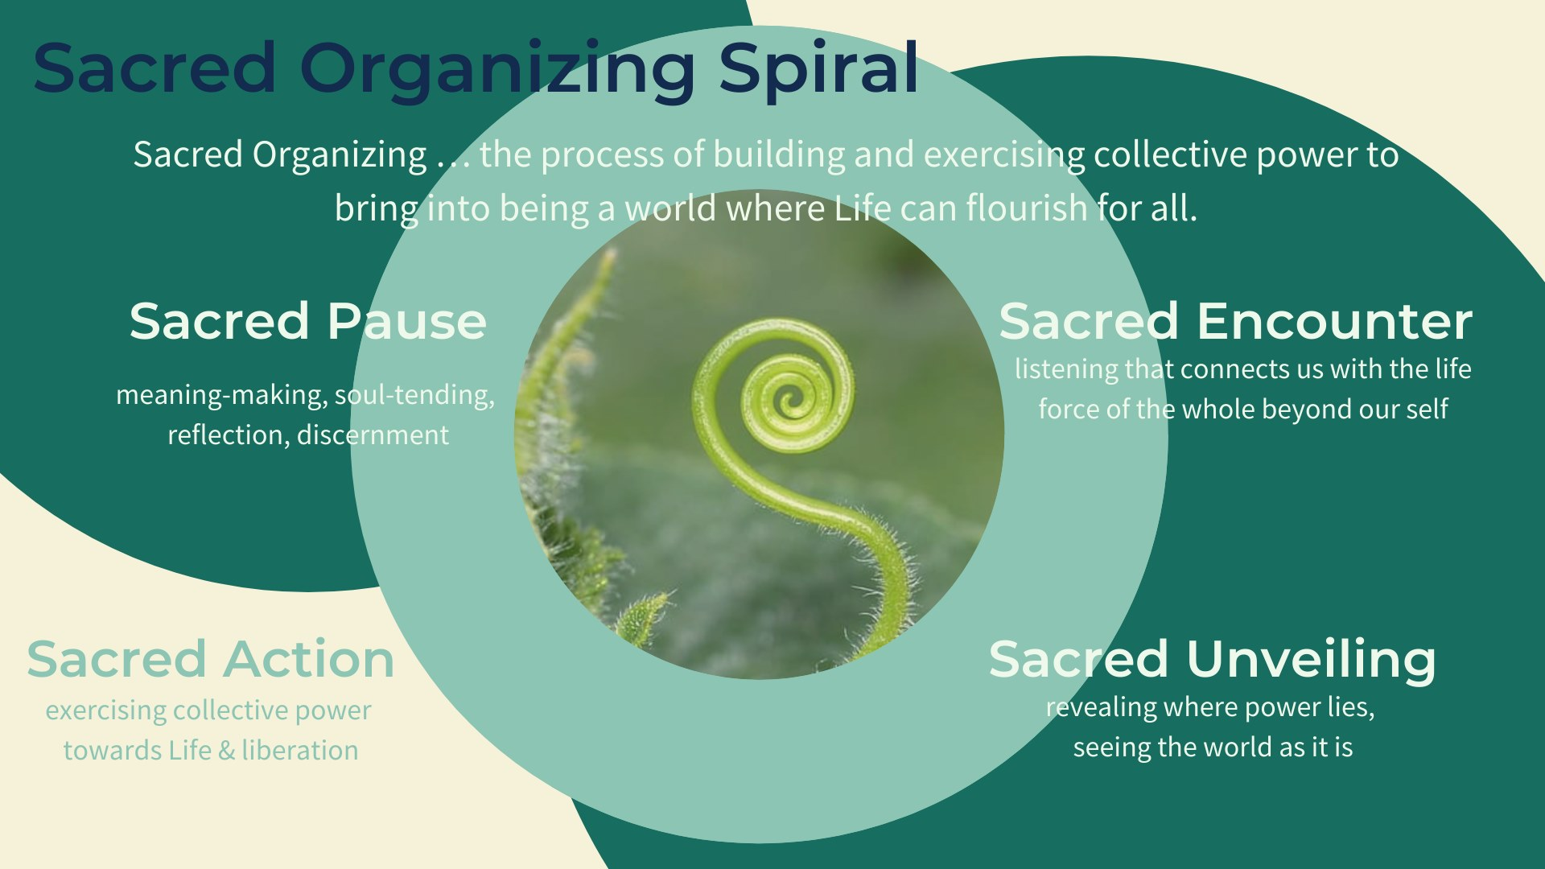

Chapter 4: practice.

"Thank you for having my back. It still reaches for you. I love you for your breath, your dense, your stubborn growth impossible. Your evolution happening right now."

- Alexis Pauline Gumbs

Transform

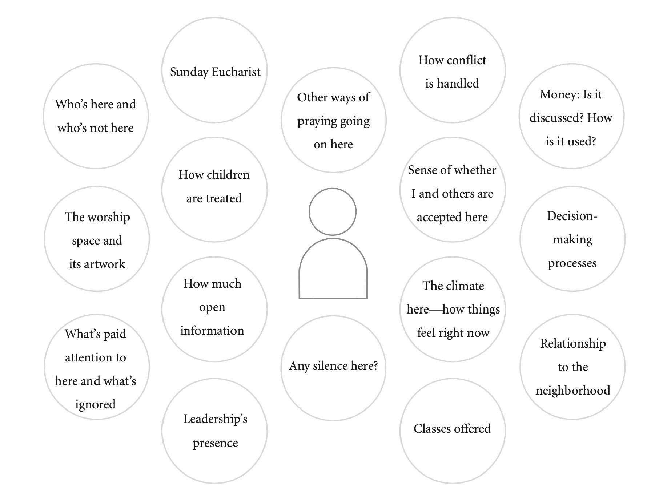

How does your community open the way for transformation to take place and where are such opportunities being stymied?

Transformation... is why any of us show up: the hope that the practice of belonging to a faith community will both renew and change us, turning our hearts more toward Christ and transforming our lives more and more into extensions of God's love in a broken world.

Sources of Transformation
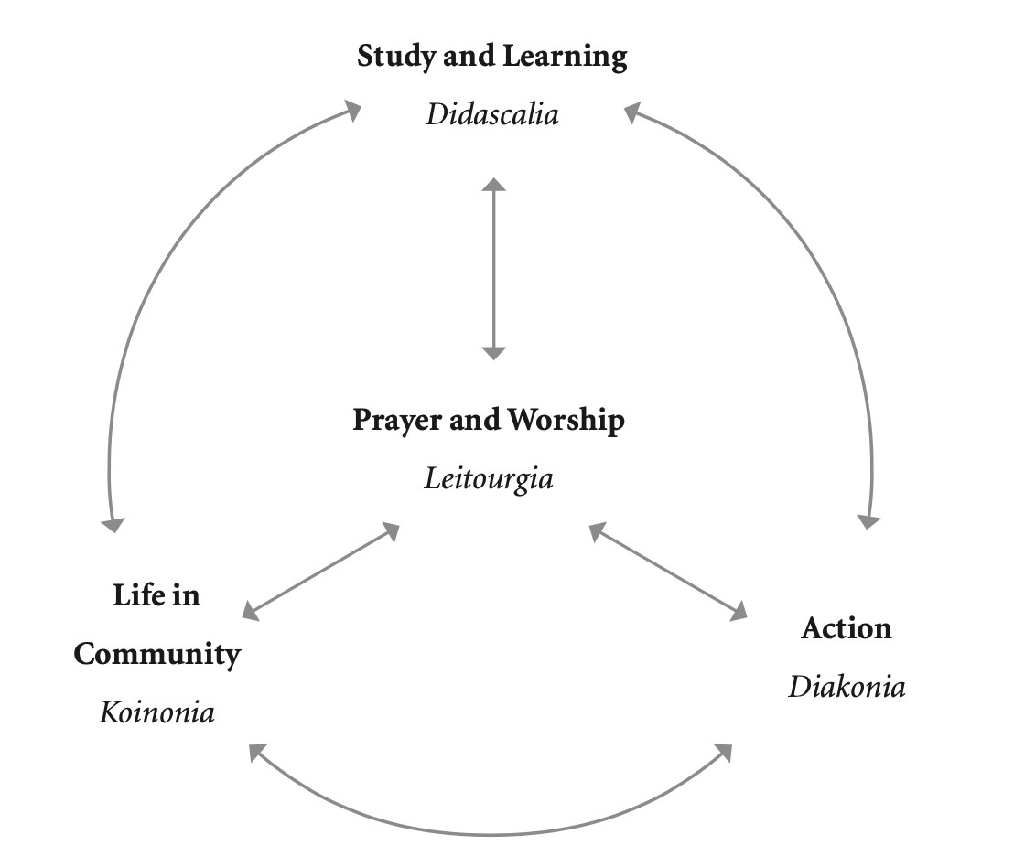

Prayer and Worship
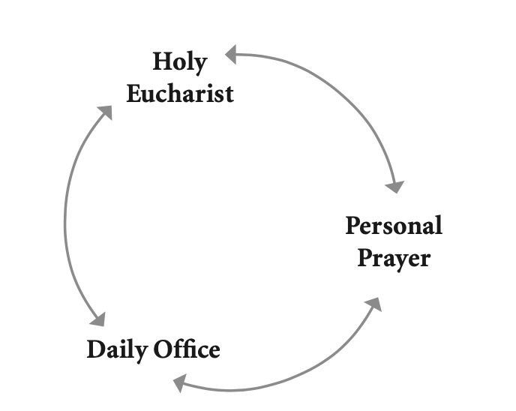

Life in Community

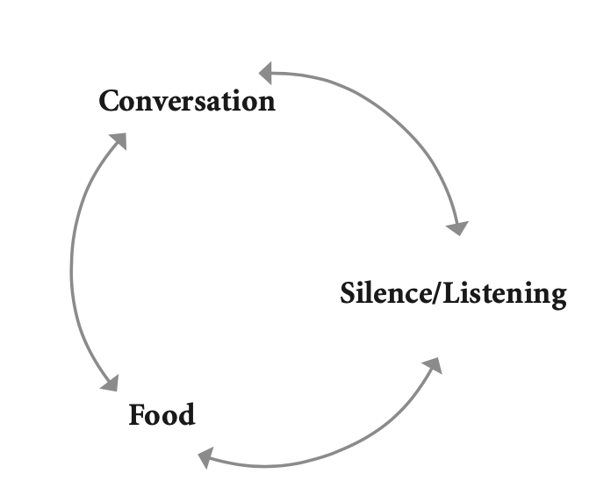

Study and Learning
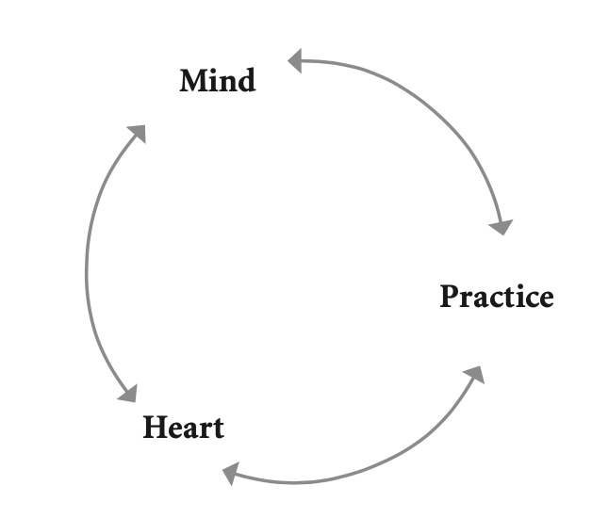

Action
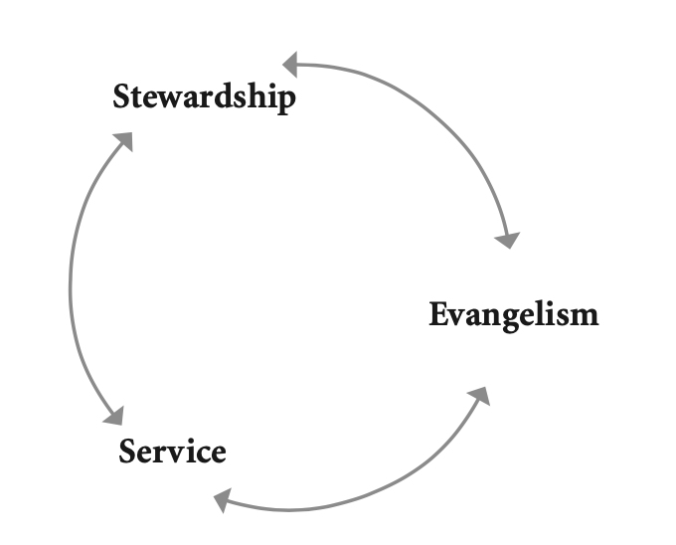

The question to ask of each area is "how can we deepen transformation?" not necessarily "how can we add more activities?"

Send

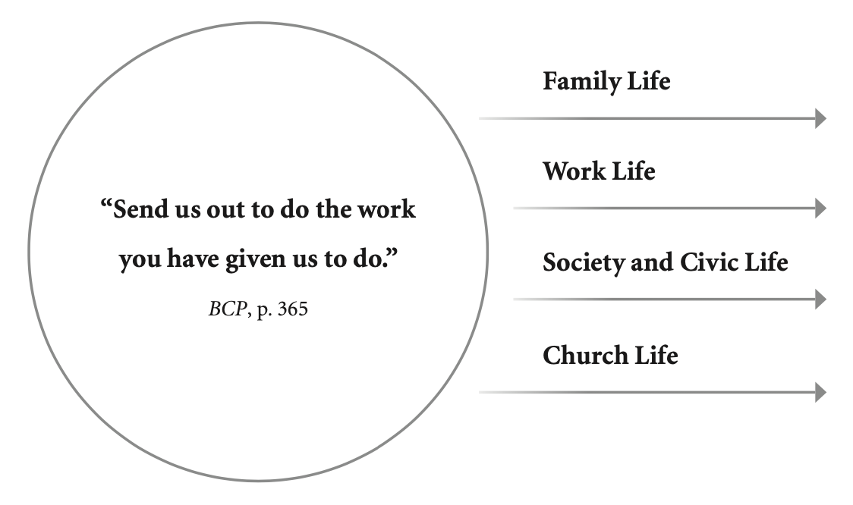
After we have gathered together and have been transformed through being accepted by the community, or learning a new way to pray, or being held in a deep silence, then we are sent into the rest of our lives to share that transformation with those whose lives are linked with ours.

"I want us to do better. I want to feel like we are responsible for each other's transformation. Not the transformation from vibrant flawed humans to bits of ash, but rather the transformation from broken people and communities to whole ones...I believe it could yield deeper trust, resilience, and interdependence."

Intentional adaptation

Change happens. Change is definitely going to happen, no matter what we plan or expect or hope for or set in place. We will adapt to that change, or we will become irrelevant.

The Gleicher/Dannemiller formula for change

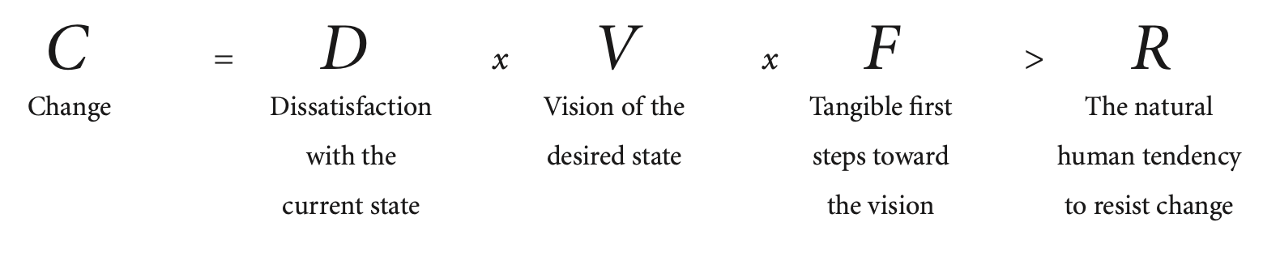
Change happens when the Dissatisfaction with the current state, multiplied by the Vision for the future, multiplied by the First steps toward that future are greater than the system's natural Resistance to change.

Think about a "successful" change you have made in your personal life and run it through the equation. What do you notice? Do the same for a change that was not sustained. What do you notice?

Articulate a concrete change that you want to make in the life of your community of faith. Analyze this desired change through the lens of the Gleicher/Dannemiller formula.

"Birds don't make a plan to migrate, raising resources to fund their way, packing for scarce times, mapping out their pit stops. They feel a call in their bodies that they must go and they follow it, responding to each other, each bringing their adaptations. There is an art to flocking: staying separate enough not to crowd each other aligned enough to maintain a shared direction, and cohesive enough to always move toward each other. (Responding to destiny together.) Destiny is a calling that creates a beautiful journey." adrienne maree brown

