VIA EMAIL: bal43rd@gmail.com, frontrangeregion@gmail.com

Balfour Patterson, Missioner
Front Range Region
The Episcopal Church in Colorado

RE: Report on Front Range Regional Grant

Dear Mr. Patterson:

Outreach and feeding is and always has been an essential part of St. Alban’s culture and “DNA.” When, in the early part of 2020, the COVID pandemic caused a suspension of one of St. Alban’s most beloved and longstanding outreach ministries – its Red Door Suppers (a free community meal offered every Saturday night), St. Alban’s prayerfully looked to alternative outreach measures to support and to feed those persons in our community.
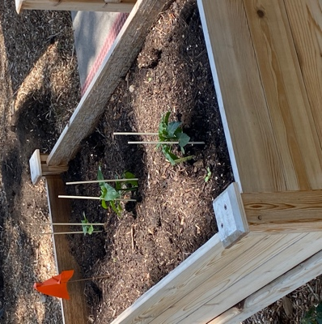
In late summer of 2020, as the pandemic intensified, a group of parishioners undertook an experiment to begin a small community gleaning garden on the parish property behind the church. In August the first two elevated bed gardens were installed and planted with a few fall crops.

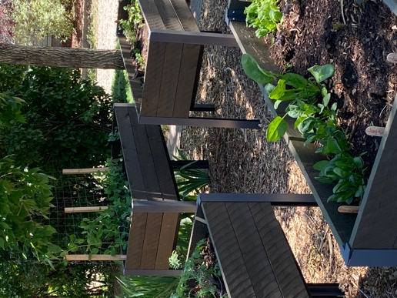
Plans were made to expand the garden the following spring. In observance of the growing community need, Spring 2022 required expansion of the Gleaning Garden. Additional elevated garden boxes funded by parishioner out-of-pocket donations added more grow space. That, coupled with additional tomato pots and three (3) in-ground squash and cucumber plants, one (1) pumpkin plant, four potato bags, and one medium-sized container for spring peas, allows St. Alban’s to continue to provide our community with multiple fresh vegetable choices.

Given the increase in usage of our Community Garden, St. Alban’s applied for and was awarded a 2022 grant from the Front Range Region to expand expand the number and type of beds in our gardens to increase the amount and variety of vegetables we are able to offer our community.

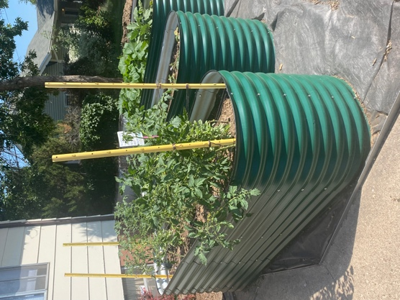
Through the grant from the Front Range Region, St. Alban’s was able to purchase and install five (5) 8’ x 2-1/2’ raised metal garden beds as well as one (1) 8’ x 8’ wooden raised garden bed to supplement our elevated garden beds. Due to the unseasonably wet May and June, the construction of the garden beds was delayed.

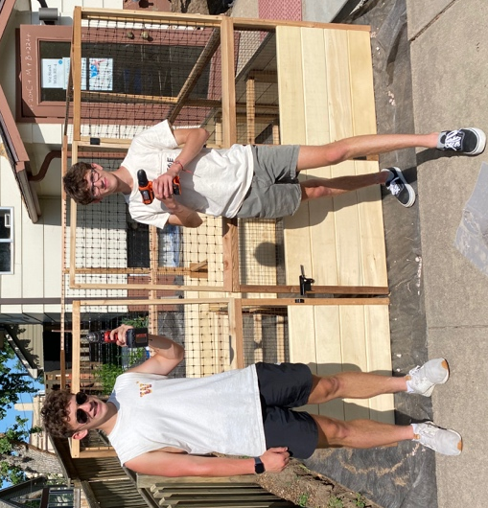
We most recently installed a Garden Gleaning Box (paid for by the funds from the Front Range Region 2022 Grant) which allows us to harvest the vegetables and display them for “gleaning” by our members and the people in our community.

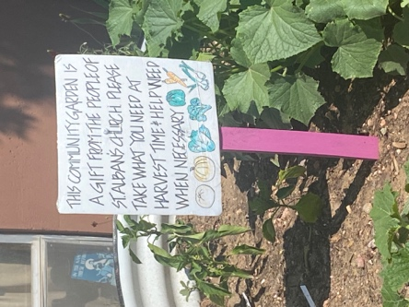
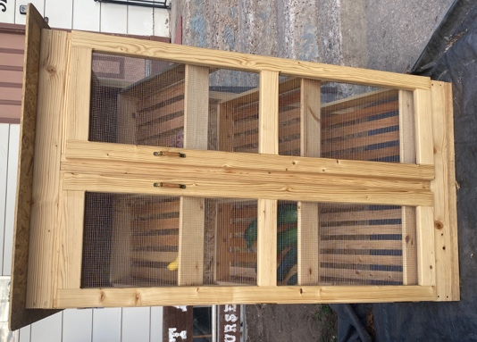
St. Albn’s Gleaning Garden and its Free Community Pantry (constructed through a 2021 Grant from the Front Range Region) has shown a light on a once unseen community of working poor and homeless in the Windsor area. Affordable housing and low-income housing is decreasing substantially in the Windsor area as new home sales are beginning at a sale price of $500,000, and apartment complexes are being sold to corporations who are raising their rents by as much as 60%. It is becoming very difficult to afford to live within the Town limits for many of the people employed in the service industry here.

St. Alban’s Gleaning Garden is within a half-mile radius of two subsidized senior living complexes and two schools and that the closest elementary school (Tozer – Title I school) currently has a free/reduced lunch population of 23.8%.

St. Alban’s mission statement is that it is the hands of Christ in a hurting world. Through the generosity of the Front Range Region of the Episcopal Church in Colorado, we are living into that mission promoting social and economic justice, alleviating poverty, and promoting wellness in our surrounding community.

Here are pictures of the “fruits” of the Front Range Region’s generosity:

