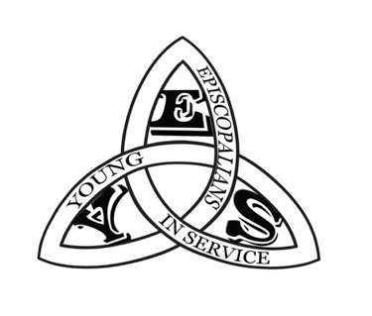

YES Colorado Mission Report

Rapid City, SD June 2022

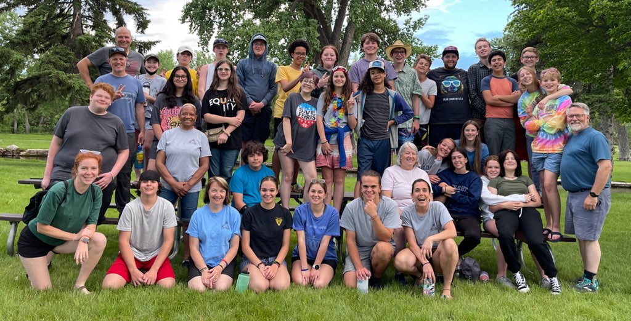

YES Colorado would like to thank the High Plains Region for its continuous and generous support of our youth mission ministry. YES Colorado has been running mission and service trips for youth in The Episcopal Church in Colorado for twelve years. Like many ministries YES was shut down by the pandemic and has not executed a trip since July of 2019. With a lot of careful planning and prayers YES hosted its first trip in two years this past June. Twenty eight youth and eleven leaders from five churches in the greater Denver area left on June 5 for Rapid City, SD.

We spent a week partnering with Youthworks Missions to serve the community in and around Rapid City. Some of the organizations we served were, Habitat Restore, Feeding South Dakota, Love Inc, Crisis Intervention Shelter, Shift Garage, Suncatcher Riding, Cedar Canyon Camp, and Storm Mountain Center. Youth and leaders worked side by side to serve in any way asked. Much of the work was very physical, landscaping, lifting, loading, organizing and processing food, repurposing home items for Habitat Restore and more. Much was learned and shared in our time with these wonderful organizations.

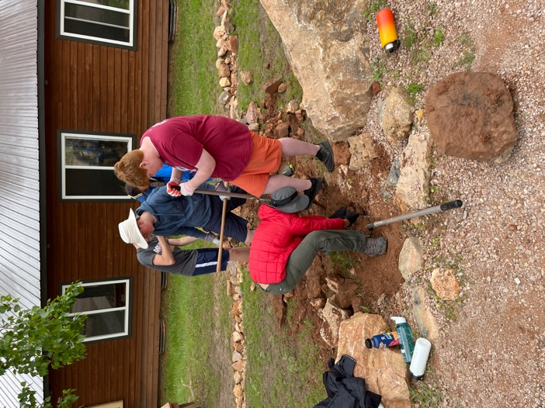 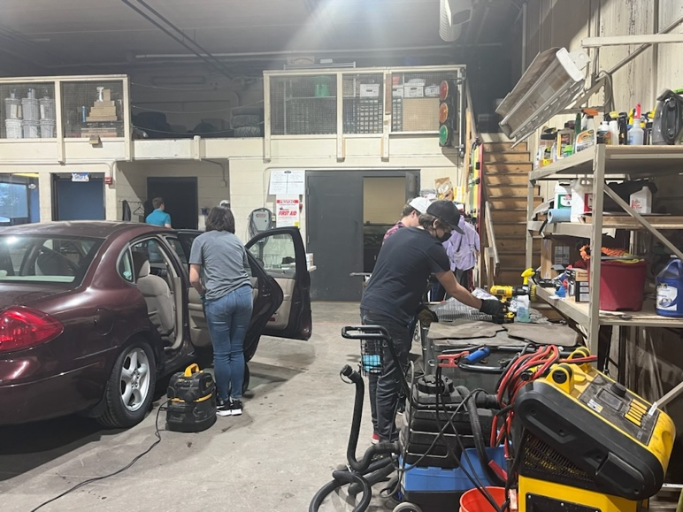

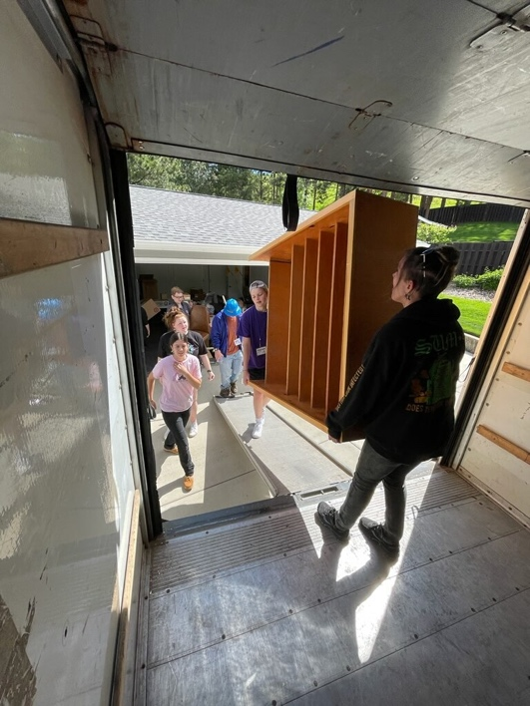 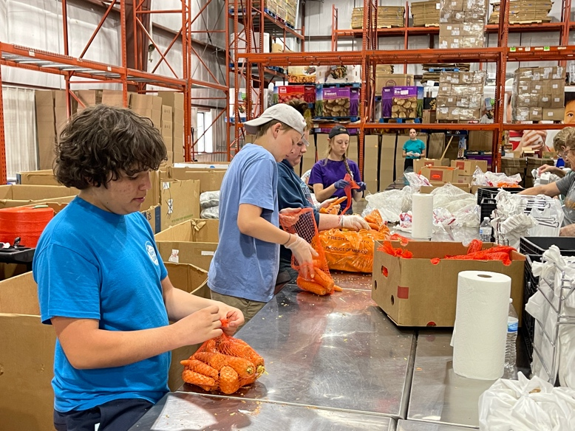

It was wonderful to be out in the mission field again with youth from around the greater Denver area and for the leaders to be in missions again. Many on the leadership team have been participating in YES trips for years. We are proud and thrilled we were able to bring back this important youth ministry, work beside and serve a wonderful community, and for one week be one community of Episcopals. We are also thrilled to report that we took 39 people away for one whole week, stayed and lived together in close quarters….and did not have one case of COVID to report. 2022 YES Missions was a huge success!

