Intercession Episcopal church, Thornton Colorado
High Plains Region 2022 Report

In November of 2021 we were able to sign a Letter of agreement with Rev. Nancy Malloy to provide us with half-time Vicar support. .We paid out $30,322.05 in Supply and Vicar salary so far in 2022. The $7,500 we are receiving is a tremendous blessing to help us cover some of these expenses. In our January budget we carried over $25,619 operating assets along with the High Plains region Grant of $7,500. We anticipate our Vicar expenses to be $39,500 for 2022.
Needless to say, as many churches also expressed, when we opened our doors in March of 2021, our Sunday attendance was significantly reduced. In 2022, we have been struggling due to four deaths and two moves of parishioners from our rolls. We however continued to service our community with our Footprints Program; providing childcare for 56 different children. Community Garden; providing 995 lbs. (3,980 servings) of produce to community food banks. 26 quilts were delivered to Precious Child, 7 quilts were given for baptisms and members moving. These quilts were made by our Quilters Ladies group.
In 2022, Intercession’s most grassroots mission was Footprints Daycare, Preschool and Kindergarten, in operation since the present building opened in 1999. We were able to stay open during the pandemic and provide care for children of the neediest families in our community. They also provided facility upgrades and contributions totaling $22,748 so far in 2022. Thornton data indicates that we have a 50.7% population of Hispanic or Latino population. On August 13th we sponsored a free community BBQ, having in excess of 90 people. We have experienced 3 new families attending our church following the BBQ. As you see from above we will be facing financial challenges in 2023 due to the loss of 6 parishioners. We have also installed video screens in our Worship space to project our services.
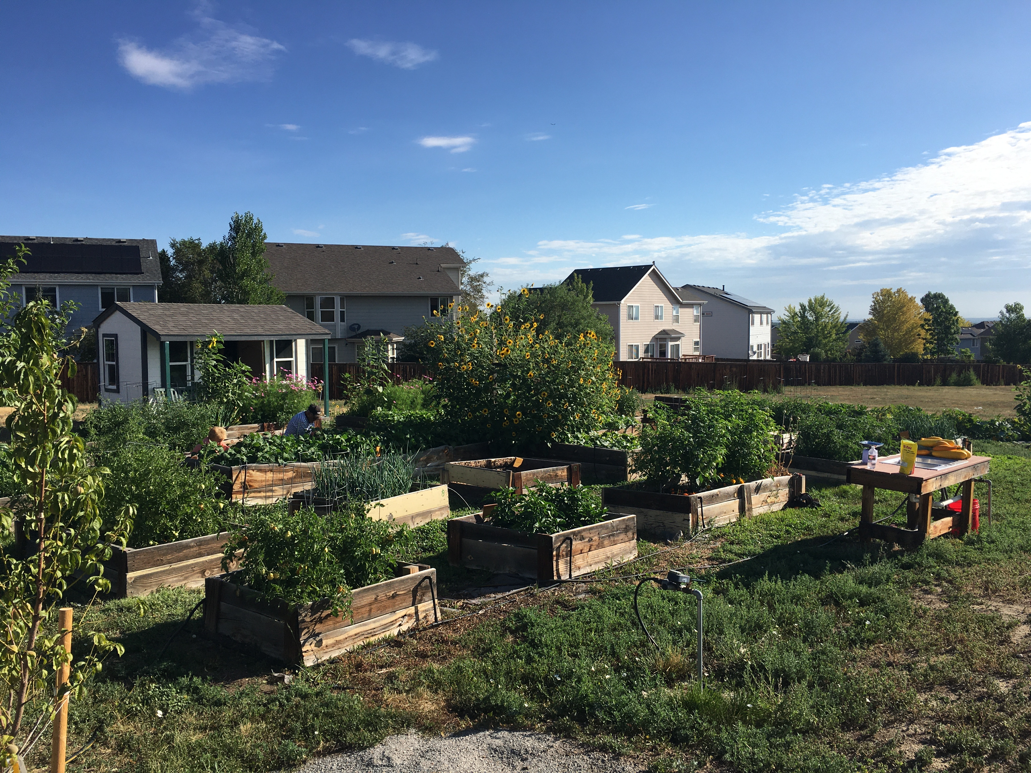
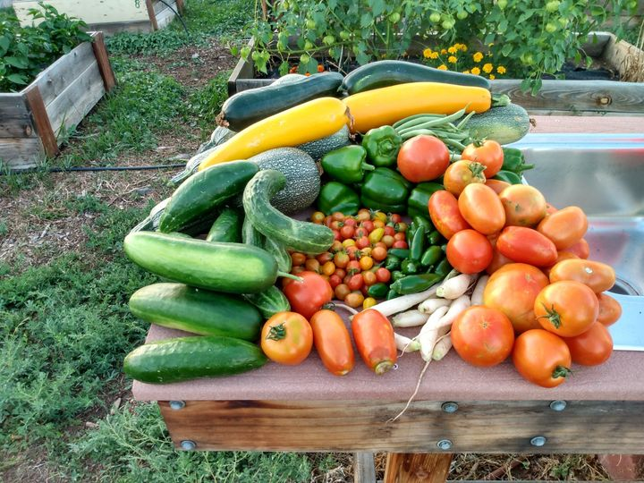
Garden Beds
Garden produce
High Plains Region 2022 Report (Con’t)

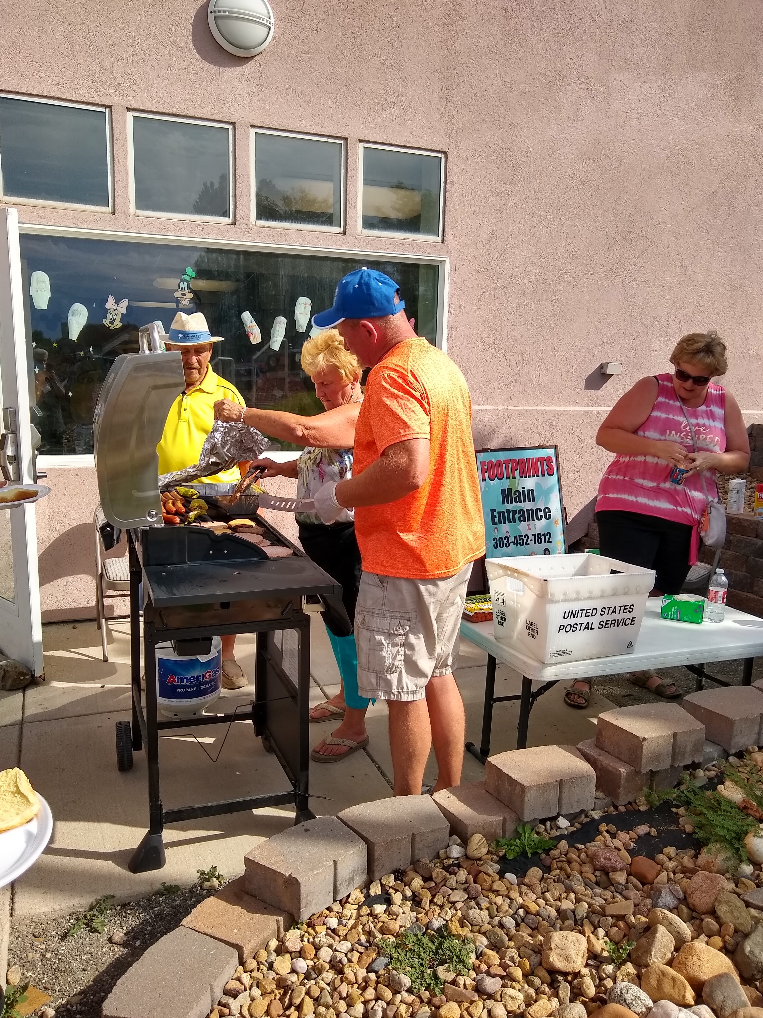
Quilt given to the firemen for their new fire station
Community BBQ - August

Community BBQ - August
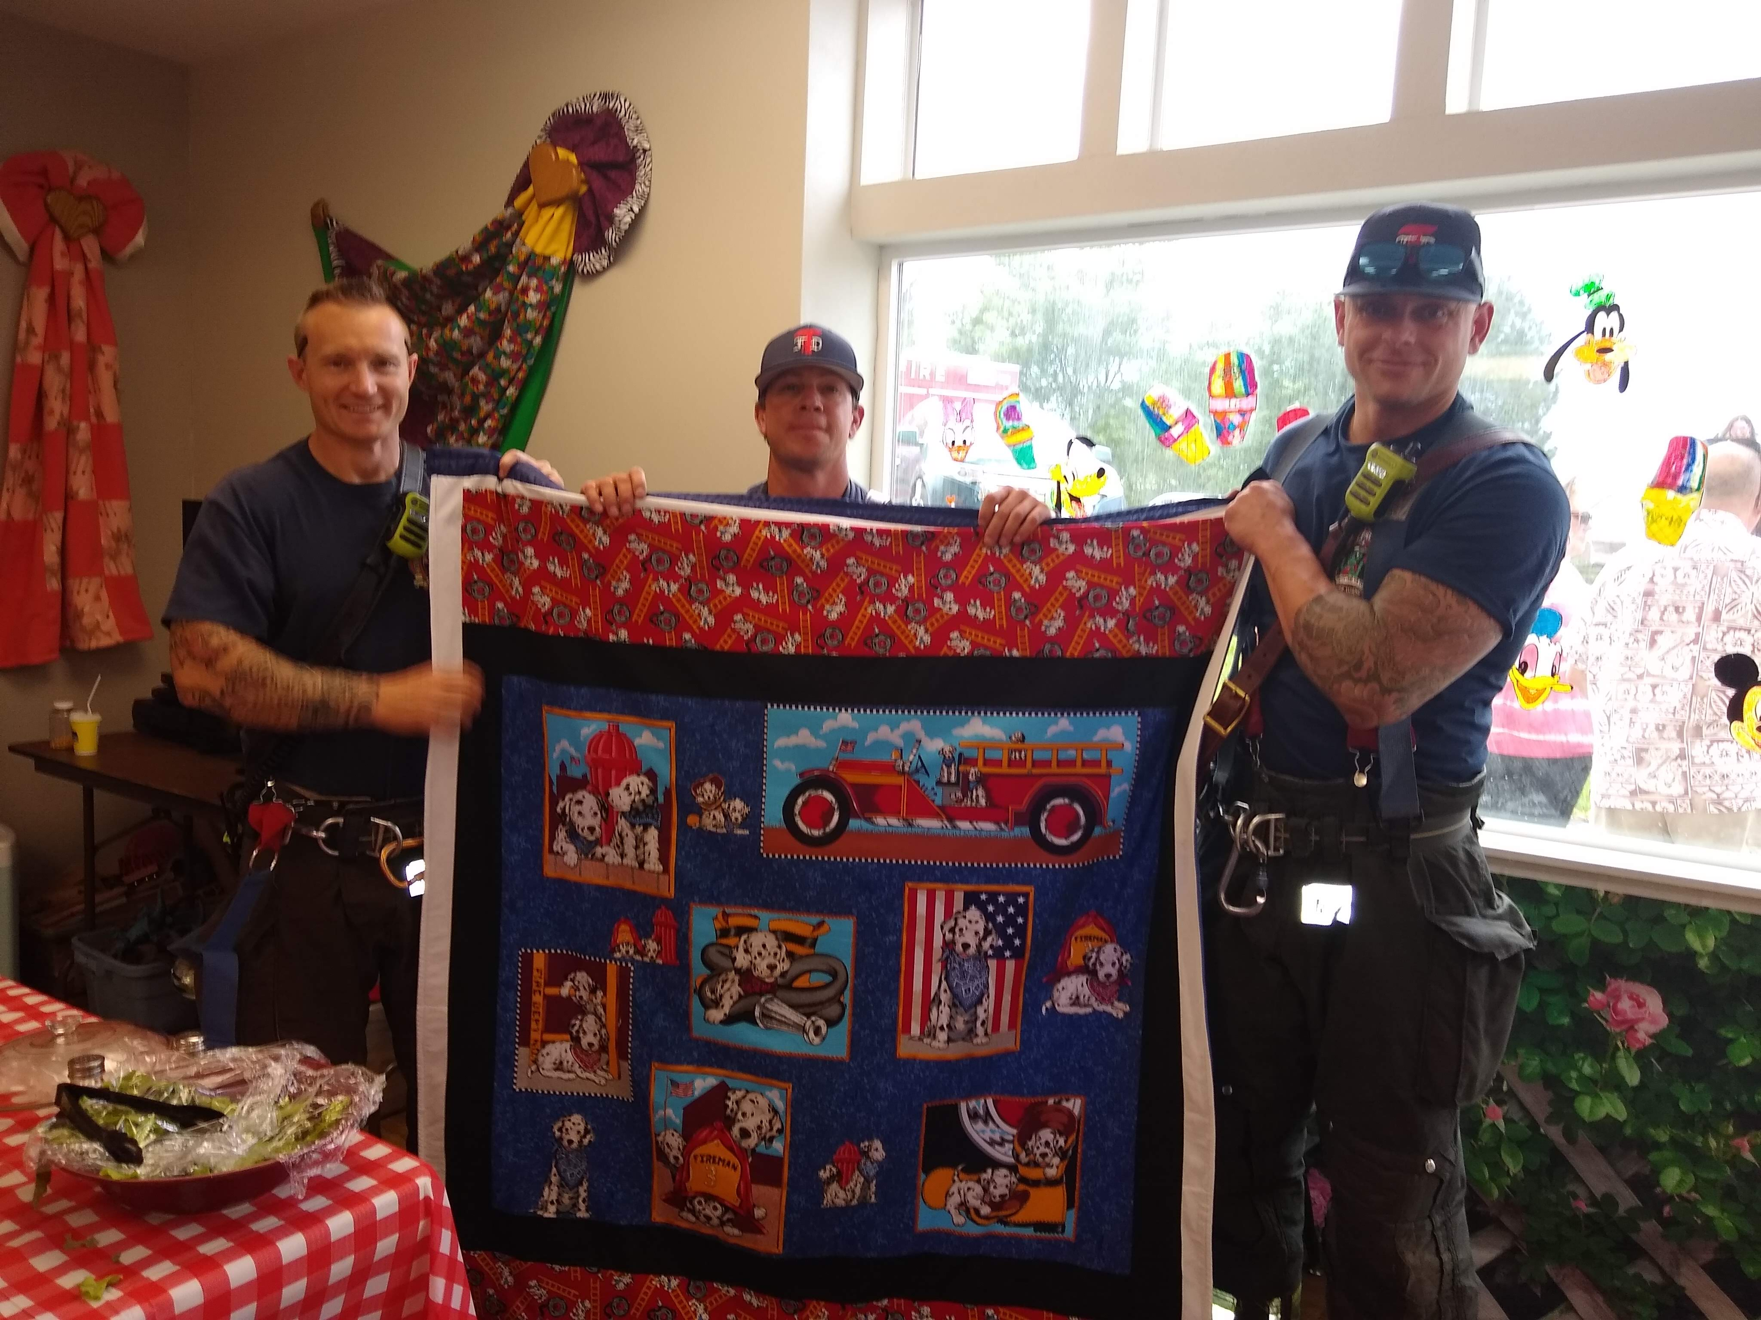
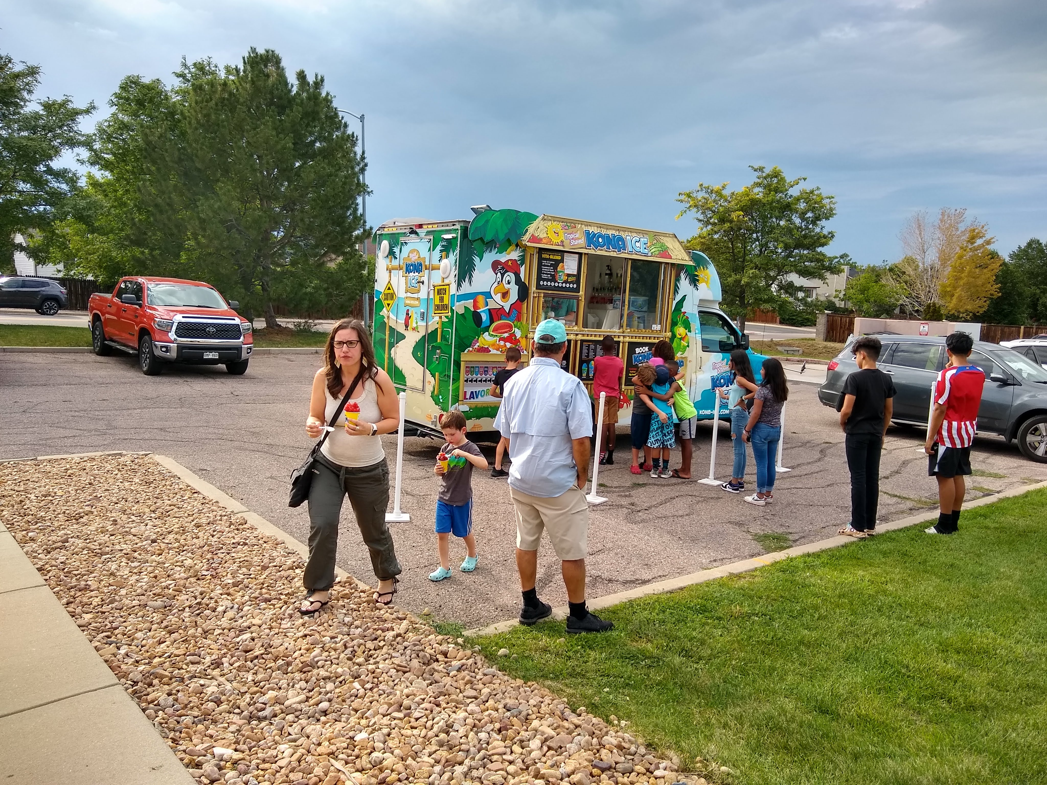
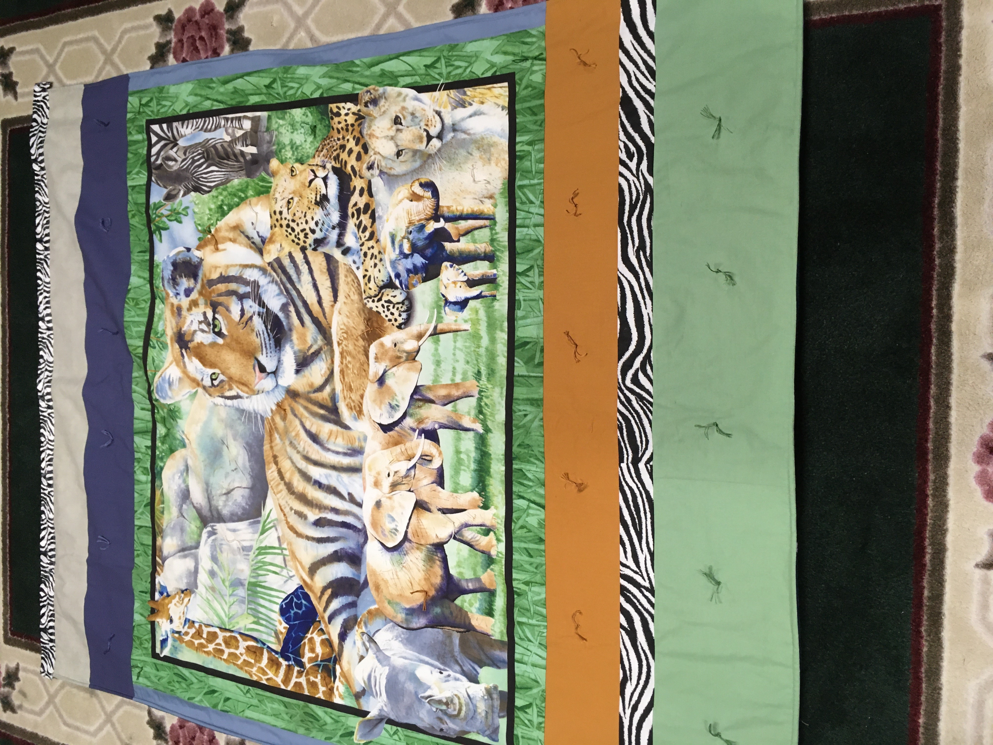
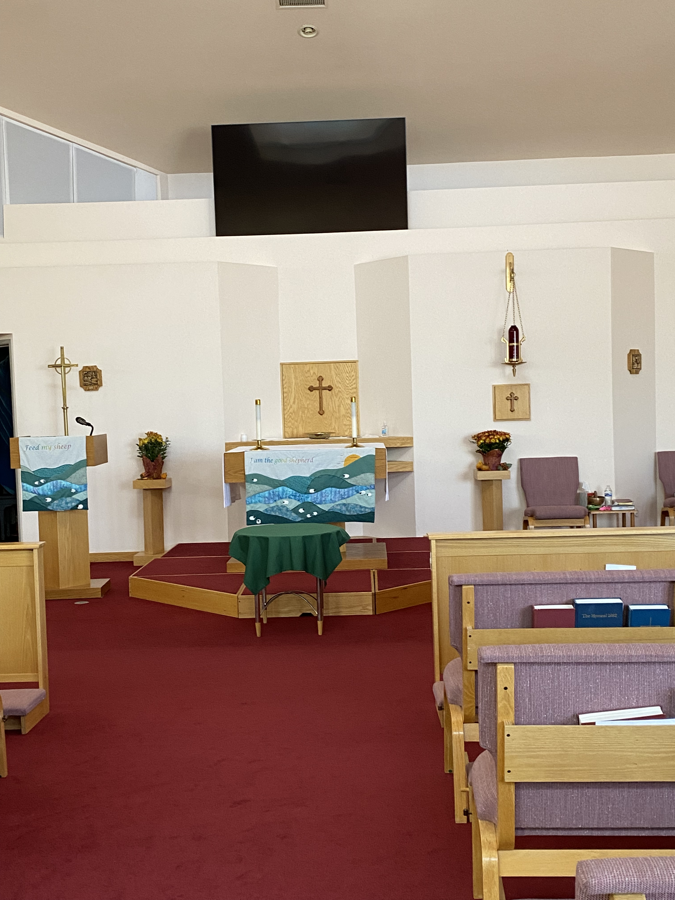

85“ Screen
Example of quilt

Submitted by John Zeaphey, Bishop Warden – Intercession Episcopal Church

