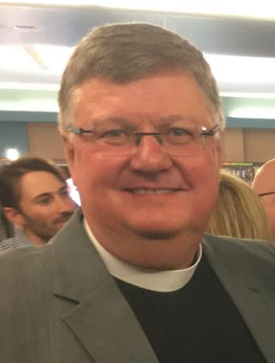**The Reverend William Stanton**

**Rector   
St. Alban’s, Windsor**

**Candidate for the Standing Committee Representative from the Front Range Region**

**Convocation 2022**

I’m the Reverend William Stanton, and I am the rector at St. Alban’s, Windsor. A native of Colorado in both life and education, I spent much of my life utilizing the Colorado higher education system: the University of Northern Colorado (BA in Sociology); the University of Denver College of Law (Juris Doctorate); Colorado Culinary Institute (AA in culinary arts – a happy detour in my life); and Iliff School of Theology (M.Div).

Before accepting a call to ordained ministry, I was a practicing lawyer (26 years) in the greater Denver area. However, God’s call to ordained ministry was greater than the Colorado Supreme Court’s call as a lawyer, so I took the skills learned and began to apply them in my new vocation as deacon, and then priest.

I grew up in the Episcopal tradition, being baptized in All Saint’s (now Our Merciful Savior) and receiving much of my spiritual formation through my home church of Intercession Episcopal, Thornton. As a deacon, I served the beloved people of St. Mary Magdalene, Gunbarrel, until I was ordained a priest; thereafter, I served as the Associate Rector for Christian Formation and Evangelism at Holy Comforter, Broomfield. In December 2018, I was called to serve as priest in charge at St. Alban’s Episcopal Church, Windsor, and was just recently called as their rector. I am a former member of the Board of the Colorado Episcopal Service Corps, a present trustee with the Colorado Episcopal Foundation, chair of the Property Committee, and sit on the Colorado Episcopal Disciplinary Board. I live in Greeley with my husband enjoying all that Northern Colorado has to give.