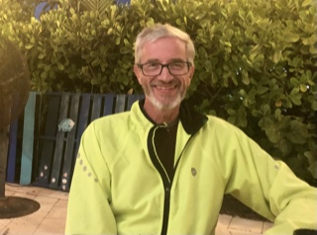Michael Shedd

Candidate for the Front Range Region Executive Committee

Convocation 2022

Raised in the Presbyterian Church, I married into the Episcopal Church 35 years ago. My wife Gina and I moved to Colorado in 2011 and to Broomfield in 2018 where we have attended Holy Comforter since. I have been a regular member of the choir, served on the Vestry, and been Junior Warden in my journey there. In that setting I learned about some of the “behind-the-scenes” issues that parishes must face. My hope on the FRREC is to continue learning how to help parishes navigate the grant process for initiation of new programs and to help respond to the occasional emergency such as the recent Marshall fire.

On a personal level, I am a physician who retired from a Pulmonary/Critical practice in Greeley to undertake, along with my wife, my single bucket list item of an epic bicycle trip. Last fall we cycled down the Pacific Coast from Canada to Los Angeles and then from New Orleans to Key West, a total of 3600 miles in the saddle.

As a physician, I learned about the critical role relationships play in facilitating good outcomes. My aim is to help foster strong relationships between the members of the FRREC and the parishes which, in turn, will help both groups to function well to the overall benefit of the diocese. As a cyclist I learned we can go a long way on mixed nuts, foil-wrapped tuna fish, and a little bit of chocolate every night; I have no idea if that knowledge will help me prepare for a role on the FRREC.