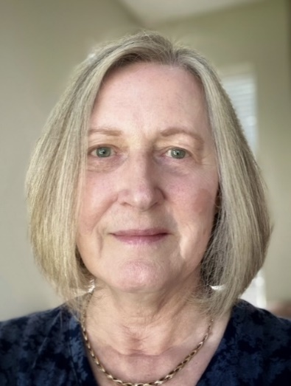**Donna Colville**

**Candidate for the Standing Committee Representative from the Front Range Region**

**Convocation 2022**

Donna Colville has attended St. Aidan’s Episcopal Church since 1998. In those 24 years, she has served as Stewardship Coordinator, two terms on Vestry, a member of the Finance Committee and as both Treasurer and Assistant Treasurer.

Donna has a background in Business Management. She has an MBA in Accounting and Finance and a BA in Liberal Arts. Along with her formal education, she has training in group process facilitation. She had a career in construction and engineering, holding management positions in both finance and in Operations.

Donna is committed to community involvement and as an avid photographer has served two separate terms as President of the Flatirons Photography Club. She also served as an Officer and Board member of her HOA. Donna is an enthusiastic gardener and cook, and along with her husband enjoys traveling and music.