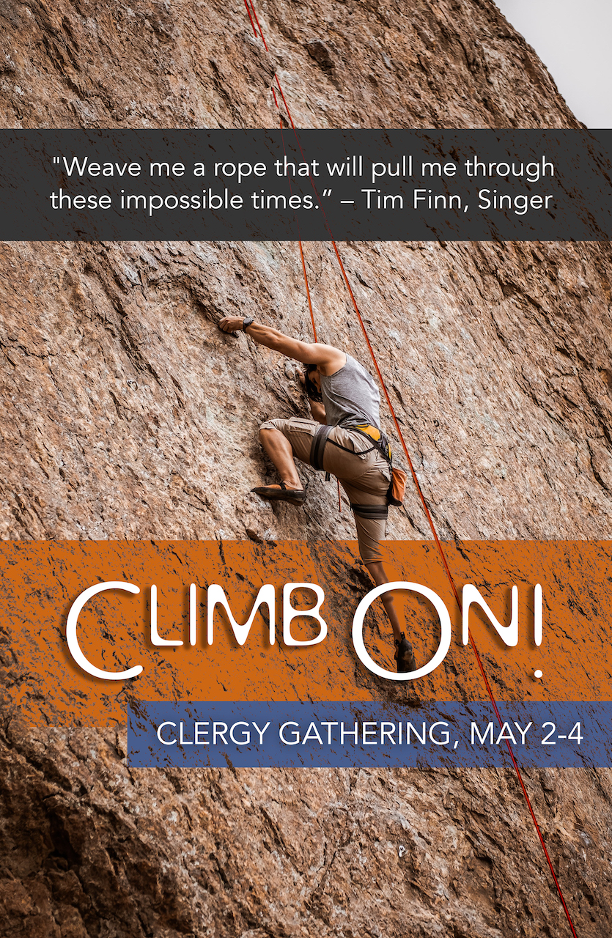
Climb On! Clergy Gathering 2022

Monday, May 2
3:00-5:00 pm Arrival & Room Check-In at Hotel Check-in Desk
Conference Check-In (Library)

5:00-6:00 pm “Connect & Reconnect” Hour w/cash bar
(Gondola Foyer)

6:00 pm Dinner, Welcome, Introductions, & Announcements (Gondola Ballroom and Foyer)

7:15 pm Bishop Kym Lucas-Opening Welcome and Introduction of Bishop Jim Gonia and Bishop Karen Oliveto (Salon II, III, IV)

8:15 pm Compline (Salon II, III, IV)

Tuesday, May 3
7:30-8:45 am Breakfast (Gondola Ballroom and Foyer)

8:30 am Silent Meditation (optional-Salon II, III, IV)

9:00 am Morning Prayer (Salon II, III, IV)

9:30 am Session #1 – Climb On!: Finding Personal Strength and Collegial Support (Salon II, III, IV)

10:45 am Break

11:15 am Session #2 – Climb On!: Building Vital Partnerships (Salon II, III, IV)

12:30 pm Lunch (Gondola Ballroom and Foyer)

Free Time:
- Spiritual Directors available by appointment (Gondola breakouts)
- Experiences: On-site Outlets and Offsite Options

1:45-4:45 pm Small group conversations with Bishop Kym, Bishop Jim and/or Bishop Karen
1:45-2:30 Session with Bishop Jim Gonia
2:45-3:30 Session with Bishop Kym Lucas
3:45-4:30 Session with Bishop Karen Oliveto

5:00-6:00 pm Session #3 – Climb On!: Joining Our Voices to Offer Prophetic Witness (Salon II, III, IV)

6:00 -7:00 pm Dinner (Gondola Ballroom and Foyer)

7:15 -8:00 pm Conversation with Bishops Lucas, Gonia and Oliveto (Salon II, III, IV)

8:00-8:15 pm Compline (Salon II, III, IV)

8:15-9:15 pm Dessert Reception (Gondola Ballroom and Foyer)

Wednesday, May 4
7:30-8:45 am Breakfast (Gondola Ballroom and Foyer)

9:00 am Silent Meditation (optional-Salon II, III, IV)

9:30 am Eucharist, Bishop Jim Gonia, Celebrant, Bishop Kym, Deacon for the Eucharist, and
Deacon Jan Pearson, Deacon of the Table
Bishop Karen Oliveto, preaching (Salon II, III, IV)

11:00 am Box lunches available to eat at hotel or grab‘n go (Riverside Foyer)
Hotel checkout and departures

