**Sharing in Maundy Thursday in an Agape Meal**

*This order of worship for Maundy Thursday is within the context of an Agape Meal to be eaten in homes with others in a congregation that joins together online from their homes.*

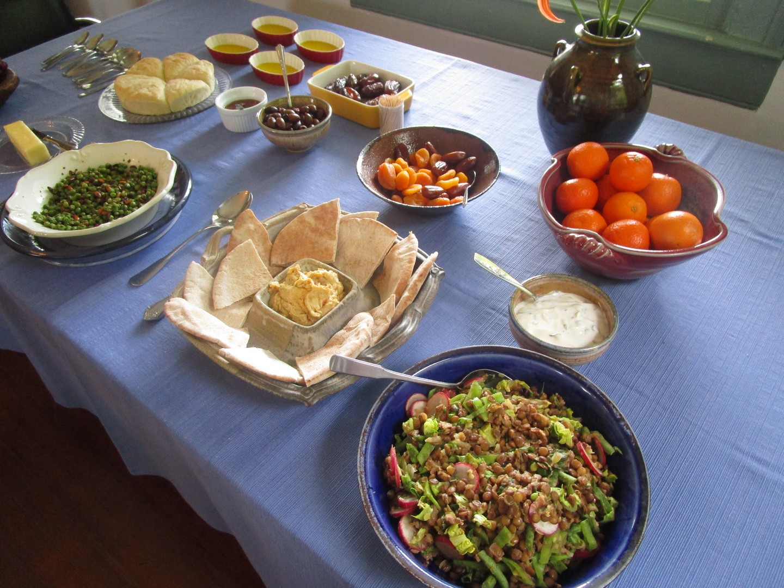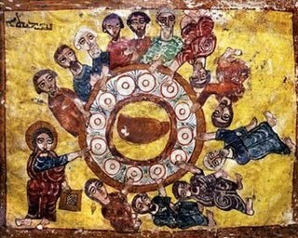

*When Jesus shared Passover with his disciples, it was in the home tradition and setting of the Passover meal. The washing of feet, the sharing of bread and wine, and the new commandment to love one another all happened in a home, in a room where Jesus drew his friends together as host, teacher, friend, and master who was there to serve them all.*

*Maundy Thursday may be considered, at its heart, a homely affair. During this extraordinary time that requires us to practice social distancing in order to help protect everyone from the rapid spread of the COVID-19 coronavirus, we are being taken back to our households as our base-point. But we have the blessing in this technological age of joining others in fellowship even when we are alone in our households. We can join now with each other on this holy night, as we pray, sing, and hear the Word of God while we eat together, each in our own homes but joined in fellowship.*

*This service weaves together parts of the Maundy Thursday liturgy within the frame of the Agape Meal as outlined in the Book of Occasional Services. It includes washing of hands. It also includes the reading of the institution of the Lord’s Supper from the Gospel according to Luke, with responses in prayer from the Didache, and with bread and wine as part of the simple meatless meal in each home.*

*To prepare your home for the service, please do the following –*

1. *Prepare a simple meatless meal to share in your home that is fitting with your own dietary requirements and Lenten fast. A Mediterranean style meal is often chosen for Agape Meals, but any foods are fine as long as they are simple. Salads, soups, simple meatless proteins, fruits and nuts, and simple grains or pastas can all be fine. Include a bit of bread and wine, according to what is in keeping with your dietary requirements.*
2. *Set your space for your meal, with a laptop, tablet, cell phone, or internet-connected screen in the room where it can be visible to everyone during the meal.*
3. *Make sure your device is connected to the internet, and download any app necessary for a shared online worship gathering where people can see one another. Most people will have had opportunities over this past month to test their sound and video input and output on their devices.*
4. *Set up what you need to wash hands. A wash basin, a pitcher with warm water, and a few towels are sufficient. If you wish to use a bit of soap, feel free. Set a hand-washing space in the room, just a bit away from the table.*
5. *Set your table with your meal, and bring a Bible and a Book of Common Prayer to the table with you. If you wish, you may light a couple of candles.*
6. *Be prepared to clear your table completely at the conclusion of the service.*
7. *At the designated time for your gathering congregation, link up to your shared online service for the beginning of this Maundy Thursday and Agape Meal liturgy. Then take your places at your table to partake in the meal and to participate as you are able in the hearing of the Word, the washing hands, the remembering of Jesus Christ’s sharing of himself in the first Holy Eucharist, and readying ourselves to follow Jesus to the Cross.*

## Gather in the Lord’s Name

*Standing as people are able,*

**A Hymn to Gather**

**Opening Salutation**

**Song of Praise, or Trisagion**

**The Collect of the Day** *(adapted)*

Almighty Father, whose dear Son, on the night before he suffered, gave freely of himself to his beloved in the washing of feet and in instituting the Sacrament of his Body and Blood: Mercifully grant that as we gather in our households we may remember these great gifts of love by Jesus Christ our Lord, and follow his great command to love one another as he eternally loves us all; who has given himself for the whole world, and who now lives and reigns with you and the Holy Spirit, one God, for ever and ever. *Amen.*

## Blessing Over the Food

Blessed are you, O Lord our God, King of the universe. You have blessed the earth to bring forth food to satisfy our hunger. Let this food strengthen us in the fast that is before us, that following our Savior in the way of the cross, we may come to the joy of his resurrection. For yours is the kingdom and the power and the glory, now and for ever. Amen

Please be seated, and let us begin our Agape Meal together.

## The Agape Meal Begins

*People are seated at their tables, begin to serve each other, and begin to eat.*

*After a few minutes, this excerpt from the Gospel of Luke and this prayer are read.*

Then came the day of Unleavened Bread, on which the Passover lamb had to be sacrificed. So Jesus sent Peter and John, saying, ‘Go and prepare the Passover meal for us that we may eat it.’ They asked him, ‘Where do you want us to make preparations for it?’ ‘Listen,’ he said to them, ‘when you have entered the city, a man carrying a jar of water will meet you; follow him into the house he enters and say to the owner of the house, “The teacher asks you, ‘Where is the guest room, where I may eat the Passover with my disciples?’ ” He will show you a large room upstairs, already furnished. Make preparations for us there.’ So they went and found everything as he had told them; and they prepared the Passover meal.

When the hour came, he took his place at the table, and the apostles with him. He said to them, ‘I have eagerly desired to eat this Passover with you before I suffer; for I tell you, I will not eat it until it is fulfilled in the kingdom of God.’ Then he took a cup, and after giving thanks he said, ‘Take this and divide it among yourselves; for I tell you that from now on I will not drink of the fruit of the vine until the kingdom of God comes.’

## Blessing Over The Wine

Let us pray.

Blessed are you, O Lord our God, Ruler of the universe. You create the fruit of the vine; We thank you, O our Father, for the holy vine of David which you have made known to us through your Son Jesus. Glory to you for ever and ever. *Amen.*

*People who have wine at their tables take a drink of wine, and continue to eat – reserving some bread and wine to share at the end of the meal.*

*After a few minutes, the Hebrew scripture is read.*

**The Hebrew Scripture** Exodus 12:1-14a

The Lord said to Moses and Aaron in the land of Egypt: This month shall mark for you the beginning of months; it shall be the first month of the year for you. Tell the whole congregation of Israel that on the tenth of this month they are to take a lamb for each family, a lamb for each household. If a household is too small for a whole lamb, it shall join its closest neighbor in obtaining one; the lamb shall be divided in proportion to the number of people who eat of it. [Your lamb shall be without blemish, a year-old male; you may take it from the sheep or from the goats. You shall keep it until the fourteenth day of this month; then the whole assembled congregation of Israel shall slaughter it at twilight. They shall take some of the blood and put it on the two doorposts and the lintel of the houses in which they eat it. They shall eat the lamb that same night; they shall eat it roasted over the fire with unleavened bread and bitter herbs. Do not eat any of it raw or boiled in water, but roasted over the fire, with its head, legs, and inner organs. You shall let none of it remain until the morning; anything that remains until the morning you shall burn.] This is how you shall eat it: your loins girded, your sandals on your feet, and your staff in your hand; and you shall eat it hurriedly. It is the passover of the Lord. For I will pass through the land of Egypt that night, and I will strike down every firstborn in the land of Egypt, both human beings and animals; on all the gods of Egypt I will execute judgments: I am the Lord. The blood shall be a sign for you on the houses where you live: when I see the blood, I will pass over you, and no plague shall destroy you when I strike the land of Egypt.

This day shall be a day of remembrance for you. You shall celebrate it as a festival to the Lord; throughout your generations you shall observe it as a perpetual ordinance.

## Psalm 78

*The Psalm may be read verse by verse, begun by the hosting site and then moving from household to household, each household reading a verse together before the next household.*

*The Psalm may also be sung by a cantor in one place, with everyone singing the refrain in their own homes at the indicated places (see below) – or sung entirely by a cantor.*

## A Hymn or Song *(such as Hymnal 577) may be used instead of the Psalm*

*People continue to eat – reserving some bread and wine to share at the end of the meal. After a few minutes, the reading from the Gospel of John is read.*

**The Gospel** John 13:1-15

Now before the festival of the Passover, Jesus knew that his hour had come to depart from this world and go to the Father. Having loved his own who were in the world, he loved them to the end. The devil had already put it into the heart of Judas son of Simon Iscariot to betray him. And during supper Jesus, knowing that the Father had given all things into his hands, and that he had come from God and was going to God, got up from the table, took off his outer robe, and tied a towel around himself. Then he poured water into a basin and began to wash the disciples' feet and to wipe them with the towel that was tied around him. He came to Simon Peter, who said to him, "Lord, are you going to wash my feet?" Jesus answered, "You do not know now what I am doing, but later you will understand." Peter said to him, "You will never wash my feet." Jesus answered, "Unless I wash you, you have no share with me." Simon Peter said to him, "Lord, not my feet only but also my hands and my head!" Jesus said to him, "One who has bathed does not need to wash, except for the feet, but is entirely clean. And you are clean, though not all of you." For he knew who was to betray him; for this reason he said, "Not all of you are clean."

After he had washed their feet, had put on his robe, and had returned to the table, he said to them, "Do you know what I have done to you? You call me Teacher and Lord--and you are right, for that is what I am. So if I, your Lord and Teacher, have washed your feet, you also ought to wash one another's feet. For I have set you an example, that you also should do as I have done to you. Very truly, I tell you, servants are not greater than their master, nor are messengers greater than the one who sent them. If you know these things, you are blessed if you do them.

"Now the Son of Man has been glorified, and God has been glorified in him. If God has been glorified in him, God will also glorify him in himself and will glorify him at once. Little children, I am with you only a little longer. You will look for me; and as I said to the Jews so now I say to you, `Where I am going, you cannot come.' I give you a new commandment, that you love one another. Just as I have loved you, you also should love one another. By this everyone will know that you are my disciples, if you have love for one another."

**Oblation Rite for Maundy Thursday**

*A Rite of Self-Offering in Times of Pandemic*

*People in their homes move back from their tables to wash their hands. During this time, hymns or songs may be sung and music may be played.*

Leader:

On this night, we recall the night that Jesus, at supper with his disciples, poured himself out as an oblation, a complete self-offering of love and service through the humble act of washing the disciple’s feet.

In these days of pandemic, we continue to offer ourselves in love and service as Jesus did, for the sake of the most vulnerable among us. And so, in an act that we may formerly have been undertaken as a self-protective and antiseptic act, we open ourselves to the transforming power of God in what is now for us a sacred act of handwashing. We do this not for ourselves, but in love and self-offering to every person we meet and especially for the most vulnerable among us.

We begin by washing, as we were washed in our baptism. We cleanse our hands as we were cleansed in the waters of new birth. We do this not because we are afraid, but because we were commanded to love, and to cleanse our hands, and gather in spirit. This how we love the vulnerable, whom Jesus loved. May we be instruments of love.

May the sacrifices we make be for the good of our human family near and far.

*One by one, each person present prayerfully washes their hands thoroughly and intentionally, with soap and water, not for themselves but sacrificially for the sake of every vulnerable person.*

Leader: Blessed be our God.

All: For ever and ever. Amen.

*Adapted and expanded from a ritual by The Rev. Josephine Robertson, All Saints Episcopal Church, Bellevue, WA and the Rev. Joseph Peters-Mathews, St. Hilda St. Patrick, Edmonds, WA*

***SUGGESTED HYMNS AND SONGS***

*O holy city, seen of John*

*Ubi caritas (Taize)*

*People return to their tables, and finish their meals together.*

*When people have regathered at their tables, this excerpt from the Gospel of Luke and this prayer are read.*

Then he took a loaf of bread, and when he had given thanks, he broke it and gave it to them, saying, ‘This is my body, which is given for you. Do this in remembrance of me.’ And he did the same with the cup after supper, saying, ‘This cup that is poured out for you is the new covenant in my blood.

‘But see, the one who betrays me is with me, and his hand is on the table. For the Son of Man is going as it has been determined, but woe to that one by whom he is betrayed!’ Then they began to ask one another which one of them it could be who would do this.

A dispute also arose among them as to which one of them was to be regarded as the greatest. But he said to them, ‘The kings of the Gentiles lord it over them; and those in authority over them are called benefactors. But not so with you; rather the greatest among you must become like the youngest, and the leader like one who serves. For who is greater, the one who is at the table or the one who serves? Is it not the one at the table? But I am among you as one who serves.’

## Blessing Over The Bread

Let us pray.

Blessed are you, O Lord our God, Ruler of the universe. You bring forth bread from the earth. We thank you, O our Father, for the life and knowledge which you make known to us through your Son Jesus. On this night we remember his giving of himself to us as the bread of life and cup of salvation. As grain scattered upon the earth is gathered into one loaf, so gather your Church in every place into the kingdom of your Son. To you be glory and power for ever and ever. *Amen.*

*People share their remaining bread and the wine in their cups.*

*People then join in prayer. Prayer is offered with intercession for*

*The Universal Church, its members, and its mission  
The Nation and all in authority  
The welfare of the world  
The concerns of the local community  
Those who suffer and those in any trouble  
The departed (with commemoration of a saint when appropriate)*

**Confession and Absolution**

Most merciful God, we confess that we have sinned against you  
in thought, word, and deed, by what we have done,  
and by what we have left undone.  
We have not loved you with our whole heart;  
we have not loved our neighbors as ourselves.   
We are truly sorry and we humbly repent. For the sake of your Son Jesus Christ, have mercy on us and forgive us;   
that we may delight in your will, and walk in your ways,  
to the glory of your Name. Amen.

**The Peace** *(bidding peace to one another online and in households)*

**Cleaning of Tables**

*People clear their tables completely, in silence. At this time, the altar in the church may also be cleared and cleaned.*

*After some minutes in silence, during the cleaning, Psalm 22 may be recited or chanted.*

*People regather, standing, at their tables, view an image together of the cross or of the first station in Stations of the Cross, and one by one close their internet connection in silence. The host closes the site last.*