St. Martin in the Fields, Aurora
High Plains Region Grant Midyear Report

St. Martin in the Fields is a small congregation located in southeast Aurora. Like many churches, our attendance and our membership declined as a result of Covid 19 restrictions. The funding we received from the High Plains Grant program was requested to help fund outreach to the community. We have been using the grant funds to increase awareness of our programing and purpose through a program that ties our use of banners on the property with our use of social media and digital marketing.
In February, at the annual Vestry retreat, we mapped out a series of “Banner Events” as a focus for our efforts. These events included: a Lenten Program (February-April), Holy Week Services and Community Easter Egg hunt on our property (April), Pride Month (June), Blessing of the Animals (October), Advent time Parent Shop night (November/December), Christmas Services (December). Additionally, the hope was to continue our outreach to the new developments in the southeast of Aurora, most notably in Copperleaf. Unfortunately, that work has been delayed by illness in the member-contact’s family.
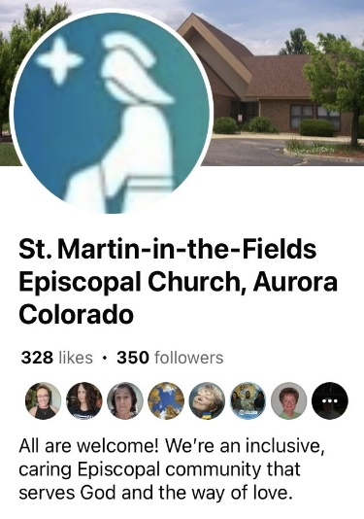
Like most churches in the diocese, we have had a website and a Facebook page for some time. We began livestreaming our 10:15 am sung service on Facebook during the pandemic shutdown. We have continued that practice and are working to improve the livestream experience. We have been having Compline through our zoom account weekly. We plan to move that to a Facebook livestream this fall. This will enable us to further market these programs to the wider community. Also, we are improving the quality of production of our livestream by making some modifications in the equipment used.

In addition to Facebook and our website, we have accounts with YouTube, Instagram, and Nextdoor. Neither our Nextdoor nor our YouTube accounts have been extensively utilized yet.
Our Instagram and Facebook accounts have been the main focus for our outreach to the community. They both tie back to our website to provide further information. We have used both video and static images on these pages. As an example, during lent we did a series of questions that were posted daily. Additionally, our static sign had a question posted that changed weekly. We also had a video posted on Instagram weekly highlighting Pastor Anna addressing the questions.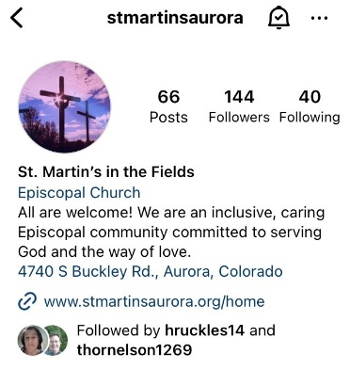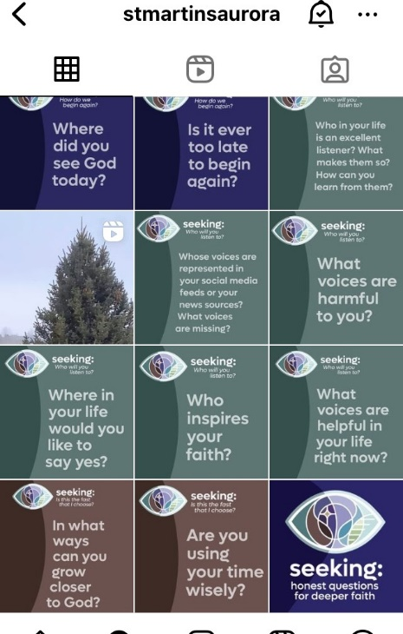

These were all coordinated with our banners:
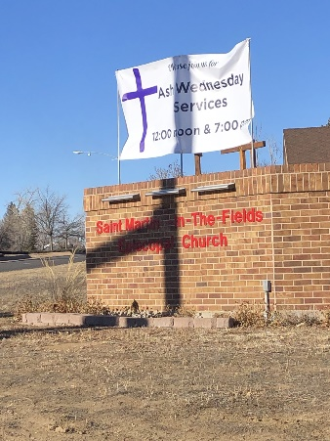
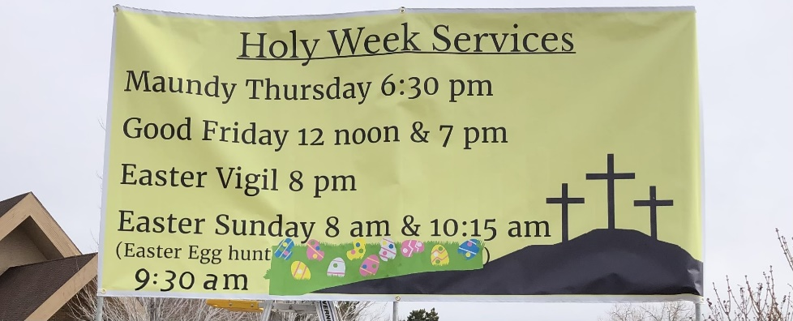

St. Martin in the Fields sits on a busy arterial road in Aurora. As a result, our banners are seen by thousands of people each week. We used the graphic provided by the diocese and created a banner for Pride Month. This banner was also highlighted on our Facebook page and our Instagram page.

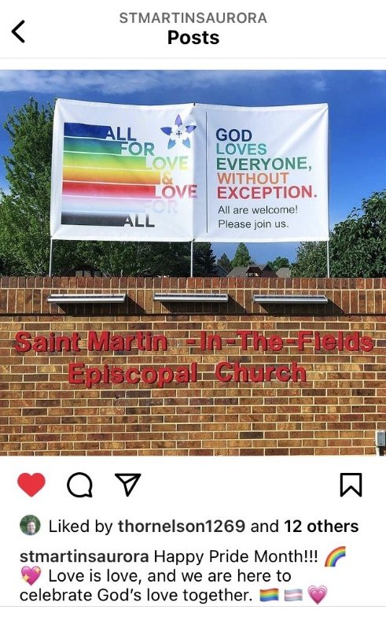

Our Pride Month banner came down at the end of June but while it was up, it touched all those who saw it with an affirmation of God’s love for them and an invitation to experience the welcoming love of our St. Martin’s community. Proof of that came in a phone call our parish administrator Claire received in the office at the end of June. A woman called from her car. She had just driven by our Pride banner. She was in tears as she spoke with Claire about how touched she was.

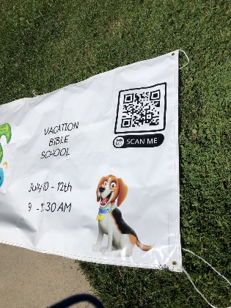
During the month of June, we also hosted a three-day Vacation Bible School event. Since we already had our pride banner up, we placed a second smaller banner near the sidewalk at the corner. To make it easy for people to get to the registration, we used a QR code on the banner that took people directly to the sign-up for the program. We plan to continue to incorporate the use of QR codes in our marketing materials.

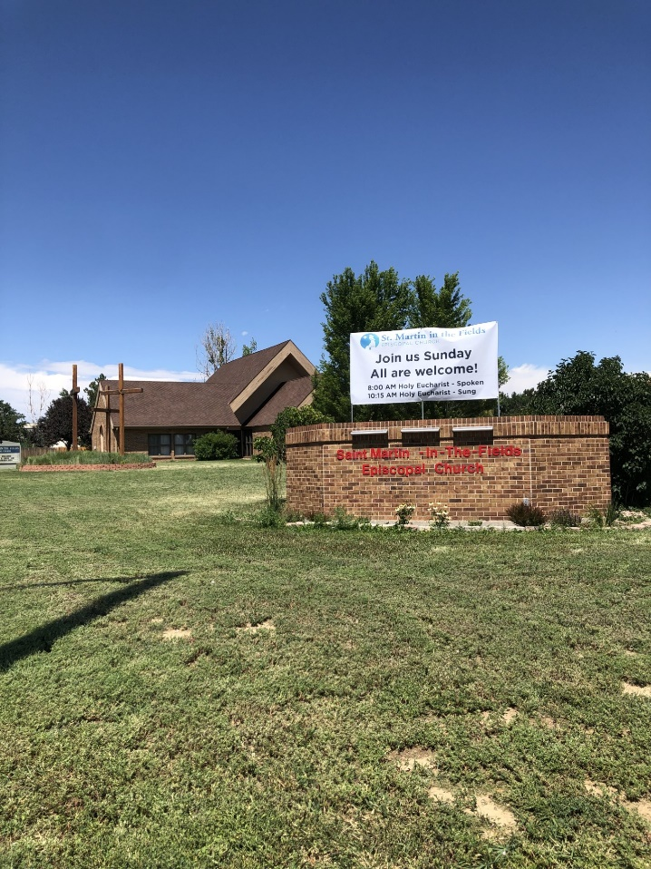
We currently have a new banner to welcome people to St. Martin in the Fields.

We are still compiling metrics on the traffic to our website from Facebook, YouTube, and Instagram. Our social media volunteer had to take an abrupt leave of absence due to health reasons. We need to find a replacement and restart our content and marketing programs. Additionally, Paster Anna was called to interim ministry at another church and our community has been transitioning on that front as well.
However, we have noted growth in our numbers on Sundays, Our Easter services this year exceeded pre-pandemic numbers. Additionally, during Holy Week, our services were well attended and children outnumbered adults at our Good Friday service!
We are currently working on the planning for our remaining Banner Events. We are so grateful for the funds provided by the High Plains which have enabled us to continue to grow our community.,

Respectfully submitted,

Ruth Ann Nelson, Senior Warden

