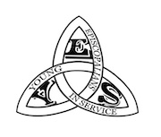

***YES Trips 2025***

***Trips and Events Report***

The 2024-2025 YES Trips program year has been such an exciting time for youth ministry. The partnership in youth ministry between retreats, camps, and trips has produced new levels of community among youth around Colorado and stronger relationships between regions and churches. Below please find a recap of all the events the regional grants funded.

***One Day Missions***

YES Trips hosted two one-day mission events (ODM) this past season: one in September of 2024 and the second in March of 2025.

At the fall ODM, a group of over 25 youth and adults served at HAAT Force in Denver. HAAT Force is a High Plains Region grant recipient that provides services for severe weather for the unhoused. They provide a large variety of services for marginalized people who often have no other resources to protect themselves from severe weather. In winter months, HAAT Force provides overnight emergency shelter. Once in the HAAT Force system, people can further receive services from a variety of agencies for food, housing, social and mental health support, and more. HAAT Force serves all people without discrimination based on race, immigration status, gender identity, sexuality, or religion. HAAT Force recently moved locations, and our day with them was focused on helping them organize their new space and set up for operations in the community.

At the spring ODM, a group of over 25 youth and adults gathered to spend the day with the St. Clare’s Ministry at The Episcopal Church of St. Peter & St. Mary. This is a long-standing Episcopal ministry which serves the homeless community in Denver. It has been a pleasure for the YES team to serve both Spring 2024 and, more recently, Spring 2025 with St. Clare’s and St. Peter & St. Mary. Our work included cleaning the building, grounds, and facility used by so many. Other work done included organizing the clothing closet, maintaining the kitchen for the meals cooked and served, and organizing the personal items space.

***June Service Trip***

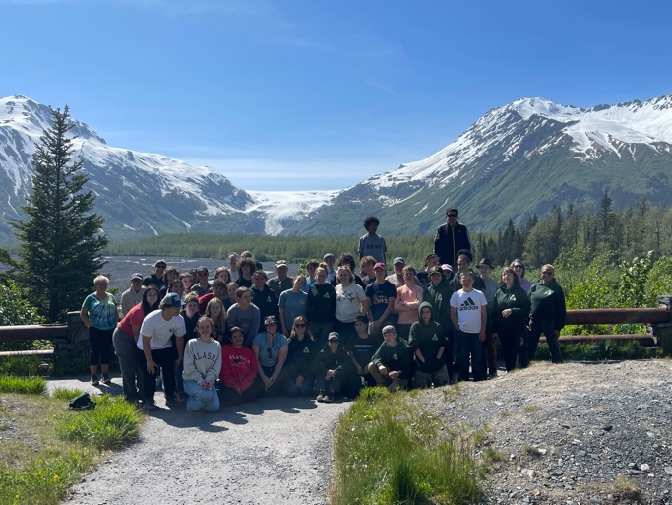

In the past, YES Trips chooses its own locations around Colorado and the country to serve. However, this year’s YES Trips was invited to serve at St. Mary’s Episcopal Church in Anchorage, Alaska. Thirty youth and twelve adults journeyed to Alaska and worked in community with on the 19.5-acre campus at St. Mary’s. St. Mary’s has been building its community-based campus for decades. The campus currently includes one of the oldest food banks in Anchorage, a senior living apartment community, a fruit tree orchard, and various community gardens along with the main church building. Our four work teams built an outdoor worship space, additional garden beds, a walking path from the senior community to the gardens and orchard. They added a lot of plants, berry bushes, trees, and more. They worked so quickly that the rector at St. Mary’s, Michael Burke, had to add more projects for our teams to complete. Our four work teams also spent a morning at Hope Studios, a division of Hope Resources, which is a residential and day community for developmentally disabled adults. During their morning, they worked with artists to create outdoor art for the gardens and orchard at St. Mary’s. That afternoon, each team went to the Alaska Native Heritage Center where they learned about all seven Alaska native cultures. This was a great way for everyone on the trip to experience Alaska native history and life.

Along with all the wonderful work, the group spent an evening in Anchorage exploring the area and amazing scenery. We were hosted by the St. Mary’s community for dinner on Wednesday evening. Thursday evening, we spent time with two native Alaskan musicians who shared their stories with us. One of the men, Aussie, taught the group a native chant he called, “Many Voices, One Heart.” On Friday, the group went to Seward for the day to explore the Sealife Center, Exit Glacier, and to enjoy great fresh seafood from local waters -- all while surrounded by the amazing scenic beauty one can only find in Alaska. Our last day in Anchorage we hiked – or more, climbed -- Flattop, which is an absolute must when visiting the Anchorage area. The group spent the day navigating this challenging climb which included a partial hike, partial incline, and partial scramble. It was an amazing experience for all, especially those who were uncertain about taking on the challenge. As each youth summited, the whole group would cheer. The supportive community we spent the week building was visibly present among the crisp Alaskan air.

Faith through community was truly the greatest impact of our week in Alaska. This group practiced faith through community the way Jesus truly meant us to. I think one of the most powerful comments I heard from a youth was specifically about the way we set up our living space for the week. She commented that she loved the one long table down the center of the room which allowed us to all eat together, “as the disciples did.” This week gave all of us better ways to explain our faith through living in community. If you cannot always describe your faith or why you follow Jesus, you can share about this week, then invite others to be a part of YES Trips in the future so they too can experience faith through community.

***Duncan Park Backpacking Pilgrimage***

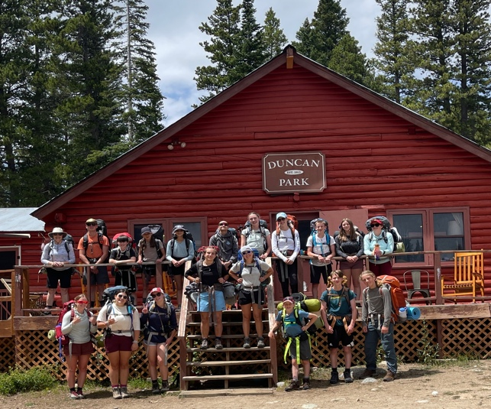

YES Trips is excited to have hosted its first backpacking pilgrimage this year in partnership with Duncan Park. Duncan Park is a camp in Ward, Colorado which is owned by the Diocese of West Texas. The Episcopal Church in Colorado is looking to build a partnership with Duncan Park by trading events with them through YES Trips and Cathedral Ridge. This July, twelve youth and four adults from YES Trips joined the staff from Duncan Park to spend a week together both at camp and on the trail. We split into two groups, one beginner and the other advanced, for the backpacking experience. Fun was had by all hikers as we navigated through the Colorado National Forest. We learned new skills for living in the outdoors for four days and great information about the area and wildlife.

Community and a focus on living into faith are always a focus of YES Trips. This week proved to be another amazing testament to youth and adults coming together as one. It was great to see how quickly youth from different churches, some who knew each other and some who just met, quickly bonded into one fun and cohesive community. The week brought much laughter, fellowship, and growth. Many of us learned new things about backpacking and had experiences for the first time. One of the things YES Trips focused on this year was the use of trip journals for formation and personal reflection time. This was also a tool we used to share gratitude for one another and the people we got to know. We hope these books will be keepsakes for a long time to come. It is impactful to have something to remember reflections and relationships made along the journey. The journals were an integral part of both the AK and DP trips.

YES Trips is grateful for regional grant support this season. Without the regional support, both the Alaska Mission Trip and the Duncan Park Pilgrimage would not have been possible for the youth of Colorado. Please visit the [YES Trips webpage](https://episcopalcolorado.org/life-in-faith/our-faith-journey/youth/yes-service-trips/) to view the Alaska Mission Trip video with youth interviews, youth sermons, and additionally the Duncan Park slide show.

***YES Trips Finances***

One Day Mission:

$300 per day in supplies and lunch for group

$600 total from regional grants

June Service Trip:

$1,500 trip cost per youth

$500 granted per youth X 30

$15,000 total from regional grants

*Important note about the Alaska trip finances. The youth were expected to earn $300 of the cost of the trip through jobs and were expected to fundraise $400 of the total cost as well. Many of the youth raised far more than $400. The additional funds were used to pay for the added activities: the Seward day, time at the Heritage Center, and the added expense of food. Food in Alaska is much more expensive than here in Colorado, and given how hard the group worked and the constant day light, this group ate more food than any other YES Trip!

*YES Trips was also awarded a separate grant for the cost of the supplies to build the outdoor worship space, additional garden beds, and paid for the materials and plants that we added. We are proud of the financial growth in these areas for a YES Trips event.

Lastly, I am very happy to report that the youth and adults on the trips this year represented 13 churches from all 5 regions of The Episcopal Church in Colorado.

We are so pleased that YES Trips is reaching youth from across the diocese.

Duncan Park Backpacking Pilgrimage:

$650 trip cost per youth

$200 granted per youth X 12

$600 in scholarships needed

$500 per adult leader X 4

$5,000 total from regional grants

YES Trips 2024-2025 Total:

$20,000 total regional grant award expenditures

*This exceeded the regional grants awarded from participating regions, the rest was offset by additional fundraising.

YES Trips, myself, the youth and their families, and the adult leaders wish to thank the regions of The Episcopal Church in Colorado for their support of this thriving ministry. By serving the youth of Colorado, we leave a footprint of service and love, all while learning who we are in Christ. Without the support of the regions many young people would not be able to attend YES Trips. We cannot thank you enough for investing in our youth, their faith journey, and the impact they will continue to have as they grow into adults who live into the love of Jesus by serving their community.

***Kimberley Hubbs***

***YES Trips Coordinator***

[***yes@episcopalcolorado.org***](mailto:yes@episcopalcolorado.org)