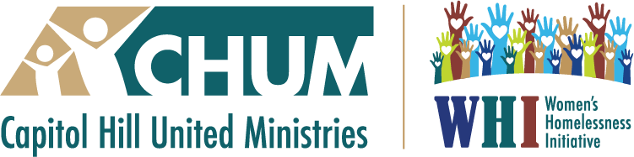 August 10, 2025
Capitol Hill United Ministries (CHUM) and The Women’s Homelessness Initiative (WHI) Team is most grateful for the past and present support from the High Plains Region for the work and witness of our programs.
It was the best of times; it was the worst of times,
It was the age of wisdom; it was the age of foolishness...
It was the season of light; it was the season of darkness...
This is part of the quote from Charles Dicken’s, Tale of Two Cities written about the late 1700s.
Unfortunately, these words resonate for today’s times. Of course, depending on what side of life’s lottery one finds oneself, in this present experience, very different realities and needs are created.

The CHUM WHI leadership and our hundreds of volunteers follow the edited version of the Beatitudes for the Modern Day written by John Alexander, S. J.
Blessed are those who have comfort and fortune, AND who are willing witnesses,
touching the pain and suffering of others.

Within this present experience of 2025, the Team of CHUM WHI continues to forge ahead with a deeper commitment to accompany those who are so being affected by the challenging policies that are radically reducing the support and care for those who are experiencing “the worst of times”, in this “season of darkness.”

The work and service of Capitol Hill United Ministries (CHUM) and The Women’s Homelessness Initiative (WHI) Team can best be described as serving our beloved community through education, engagement, and service. This includes clothing those in need, feeding the hungry, inviting in the stranger, helping with housing, supporting local unhoused agencies and their guests, and offering a place of solace, education, purpose and conversation for the community. And a the same time being fluid to respond to needs as they arise.
The Women’s Homelessness Initiative (WHI), coordinated through Capitol Hill United Ministries, was created by CHUM to meet the need for more shelter space for women in a safe and welcoming environment. This successful ministry consisted of a consortium of congregations, agencies, organizations, and approximately 1,000 volunteers that offered overnight sanctuary every night for approximately 90,000 women who were unhoused. This was done in coordination with our partner agency, the St. Francis Center. Many of our guests were able to find permanent housing, which continues to this day.
Years after our overnight sanctuary sheltering, many of our women who found permanent and supportive housing, continue to praise the work done by CHUM WHI. Rosalinda Sanchez articulated, just a few weeks ago, how CHUM WHI literally saved her life. Many of the women given sanctuary, have safety and home to this day, due to our work and passion to make a difference.

When COVID came and changed the unhoused landscape, the CHUM WHI teams quickly responded to the new developing community needs. CHUM WHI’s goals continue to be: to serve those in need, educate our community, and create opportunities for advocacy for those in our community who wish to volunteer and make a difference.
Blessed are those who do not resent the poor or the homeless and who are able to open their eyes and hearts and see them clearly with the eyes of love.
Each day, we continue to supply breakfasts or lunches, covering nine agencies every week. That is over 450 meals every week, or nearly 2,000 lunches each month, with hundreds of people in our volunteer community donating the cost of the food, making and delivering meals to feed those in need. Those agencies receiving these meals continue to share their gratefulness. The interaction of those who make and deliver the meals provides those serving with real experiences in meeting and seeing those who tend to be invisible. It provides our volunteers with a new understanding of what it is like to be unhoused and the challenges they must face every day. When there is a need to financially support these efforts, CHUM WHI does so. The in-kind costs to provide these meals equals $72,000 a year.
Blessed are those who are generous of heart, who give of their love, their resources.
And keep on giving despite disillusionment and disappointment.

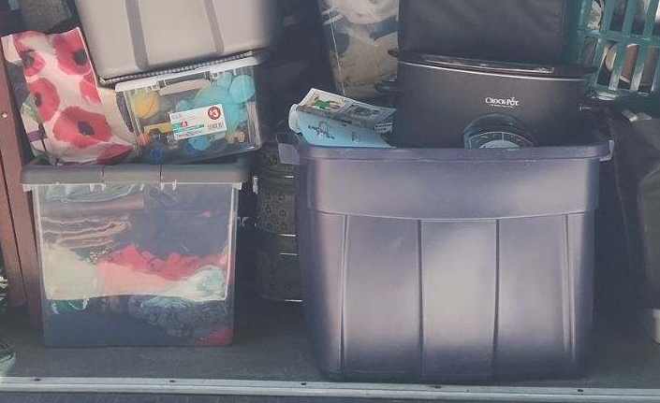
For the last 5 years our amazing team has continued our monthly coordination of gathering, sorting, and deliveries to 7 partner agencies, who list the specific items they need. We give thousands of dollars to donations of clothing, food, water, medical and personal supplies. In addition, CHUM WHI provides approximately $10,000 a year towards purchasing these supplies.
The financial support of High Plains helps us continue this work.
Blessed are those who respect a person as an individual and do not prejudge them because of their race, color, ethnic or economic background or sexual identity. They do not reduce that individual’s life and gifts and hopes for a free and better life, to one characteristic.
CHUM WHI’s work with newcomers has grown and continues. We are working with 3 families who have come to this country seeking sanctuary, hope, freedom. These last months have created a sense of fear and uncertainty in their lives.
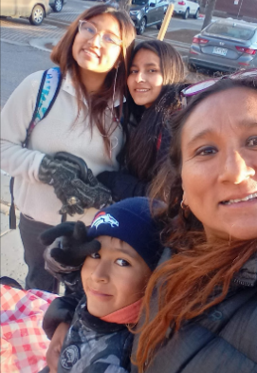
As our CHUM WHI team always does, we responded to a new need, creating Circles of Care, another CHUM WHI program of support for those in need. Our Circle of Care Team continues to provide a comprehensive program to support newcomer family units around the issues of housing, legal issues, summer programs, school, before and after school programs, recreation, transportation, work, ESL, medical, food, etc. The CHUM WHI team through Circles of Care has created another volunteer/mentor group and presented various programs on this vexing issue in our community. Although these families have been moving towards a level of self-sufficiency, the policies
of this new regime has created such a deep level of fear that just the mundane of life: going to school, to work, getting medical support, going to the grocery store, has become seriously challenging. There is a clear sense of uncertainty and danger that didn’t previously exist. This new level of fear has caused serious hardships, on so many levels. CHUM WHI has committed to accompanying these families, while we are able.
CHUM WHI has been able to help financially with their legal fees, rent and other needed expenses. We have spent approximately $15,000 this year.
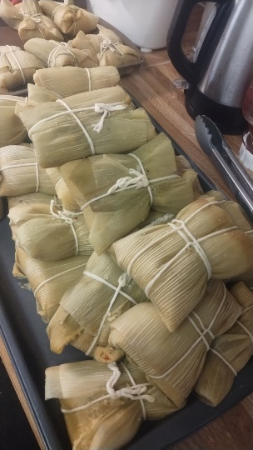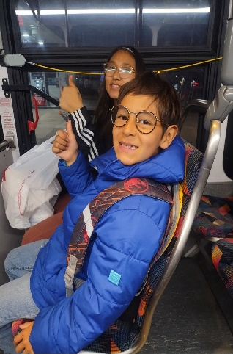
In addition to the above continuing programs, the CHUM WHI TEAM has also:
- Created a community program, “The Power of One, Power of Community...a Sacred Gathering.” It was held at 10 different sites, where various congregations and community spaces , at the same time to grieve, to hope, to pray. The Council of Churches worked in collaboration with us for this program and we plan to offer it again.
- A well-attended and successful program and conversation on Empathy was offered, with the facilitator being a Professor from the University of Florida.
- Members involved with CHUM WHI have spoken at a variety of churches and programs about our work
- Diana Flahive, Executive Director, has been a team leader for the Interfaith Immigration Network and Journey with Migrants
- Diana Flahive has planned meetings with The Gathering Place and Family Promise to see what might be possible in the future.
- There are a variety of other programs on the docket.
Capitol Hill United Ministries (CHUM) was founded over 30 years ago as an interfaith organization comprised of over 50 congregations and service agencies operating in the heart of Denver, with the purpose of creating collegiality among various congregations and nonprofit organizations, to share information, celebrate together, and educate and advocate for our neighbors in need, especially around issues affecting those who are marginalized. Our mission is to be a spiritual presence and resource in the inner city of Denver, and to strengthen and sustain our member communities, particularly through effective communication and cooperation.
CHUM WHI continues to be resilient and move with the needs of the community by innovating and gathering the resources to respond. Many volunteers feel they are blessed to be able to have our organization provide opportunities for community, and for having a conduit to be in service and contribute to the call. The multitude of congregations in our CHUM community continue to be provide active volunteers who give so much of their time, talent and treasure. We can only accomplish the above by recruiting congregations, community groups, families, and individuals to join our cause.
We are presently supporting the work of The Gathering Place, St. Francis Center, the Delores Project, Network Coffee House, St. Francis Outreach, Warren Residences, SFC Senior Residences, the Denver Public Library, Urban Peak, Colorado Coalition for the Homeless, EarthLink’s, and the Circles of Care. Depending on our programs we also offer opportunities to the larger community for education and dialogue on important issues, as they arise.
CHUM WHI has continued to serve those who are marginalized. And we have given opportunities to support those who have a need and desire to give and make a difference.
Like the miracle of the loaves and fishes, involvement with CHUM WHI, only multiples in many other significant ways throughout our community.

This work does not happen in a vacuum or without great dedication, creativity, organization, communication, and effort. The CHUM WHI team continues to do this work on a comparatively small budget. Funds are needed to continue this good and essential work.
The High Plains funds we receive are used for continuing the work of serving lunches and breakfasts and bringing needed supplies to those in the unhoused community and the responsive needs that develop with our community at large.

Diana J. Flahive
Executive Director CHUM and WHI
(303) 257-8588 - cell
www.chumdenver.org
dianaflahive@chumdenver.org


