2024 Grant Review

Prince of Peace Episcopal Church, Sterling, Logan County, Colorado

High Plains Region Church Assistance Funds

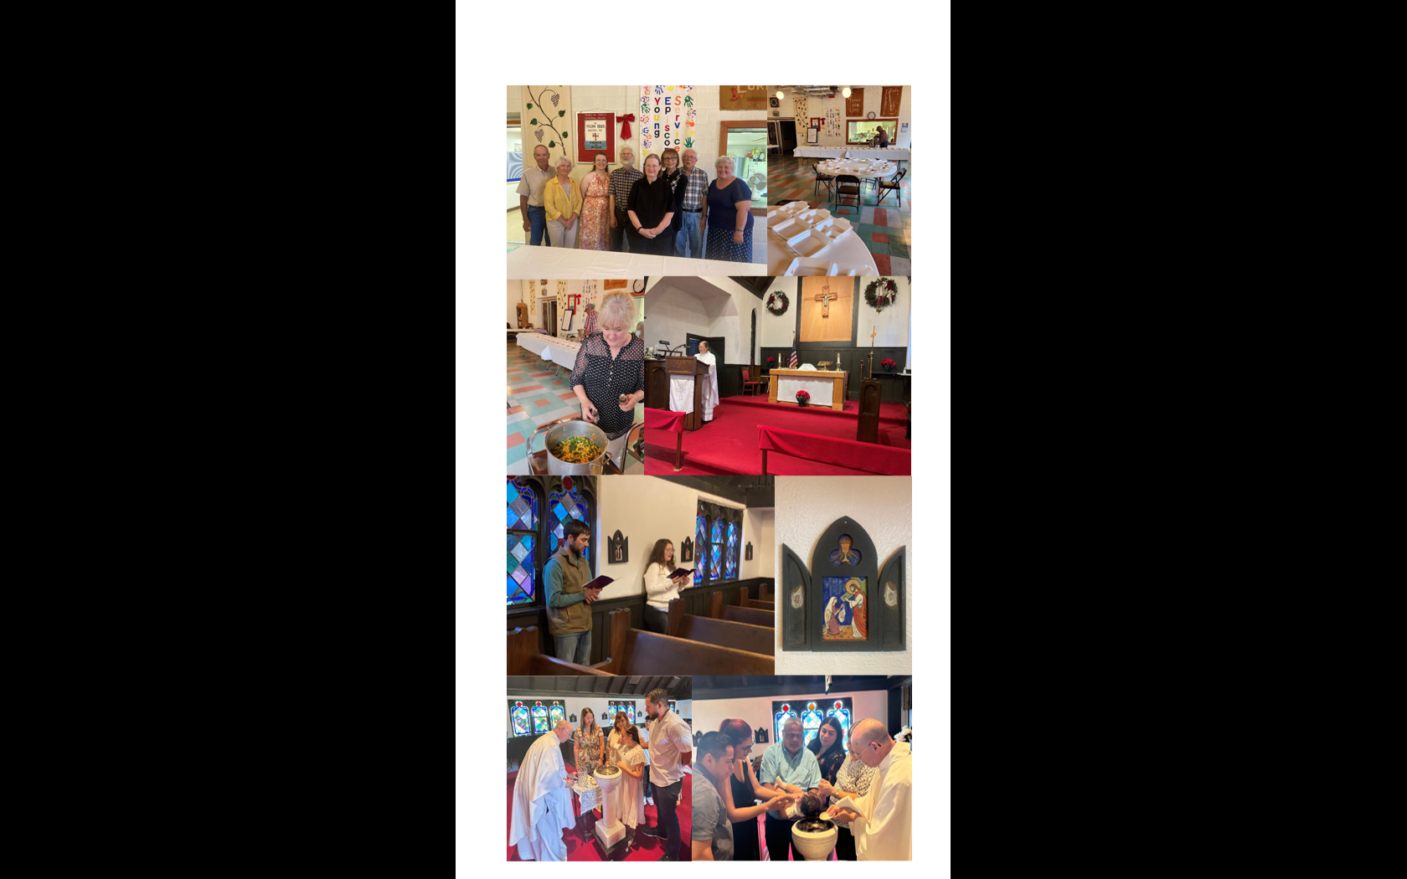

About Prince of Peace:

We are a small church in northeastern Colorado, who rely on supply priests and Morning Prayer for our weekly worship services. Each month, the parish has one Saturday evening Holy Eucharist followed by a fellowship meal and the other weeks the congregation has Morning Prayer on Sundays with the help of two young adults. The year’s highlight of our spiritual life was to witness this June, the baptism of a baby boy and a young girl of Puerto Rican parents. An Episcopalian grandmother from Puerto Rico was able to travel to Sterling to partake in this blessed event.

How is the Prince of Peace Church involved in community outreach?

Having underutilized space, the non-profit organization “Under the Umbrella” uses our facility to prepare carry out meals twice a week for 60 to 80 people in need. Also, Under the Umbrella has a food pantry and a clothes closet. Once a month, the HALO group uses our parish hall to pack 60 to 90 kid’s food boxes. At Christmas time this group uses the Prince of Peace parish hall for a Toys for Tots event.

Church Assistance:

First and most importantly it helps the parish to have a monthly supply priest. As for physical upkeep, the Prince of Peace Church finally upgraded the lighting in our parish hall entrance from fluorescent lighting to a more energy efficient LED lighting. After finding a reasonable and knowledgeable sprinkler repairman, we were able to upgrade the church lawn sprinkler system. Then there are the expenses of heating and cooling an old structure, not to mention a $2,655.50 (quarterly) church insurance bill.

Although small in number we feel it is important to nourish each other, provide a place to worship, and be involved in community outreach. We greatly appreciate the support and encouragement of the High Plains Region through this grant.

Thank you!

**Prince of Peace Church:** 201 Phelps St., Sterling, CO 80751

**Phone:** 970-522-0539

**Office Hours:** M, W, Fri.

**E-mail:** [princeofpeace@kci.net](mailto:princeofpeace@kci.net)

**Web Site:** [www.princeofpeacesterling.org](http://www.princeofpeacesterling.org)